

ITI Examination System

**Prepared By**

**Omar Adelhady Mostafa Maatouk**

**Ahmed Hassan Mohamed Hassan**

**Ziad Mohamed Ali Mohamed**

**Doaa Mohsen Abdelfattah Mohamed**

**Ahmed Abdelhamed Hussein Mohamed**

**Supervised By**

Eng. Eman Gomaa

INFORMATION TECHNOLOGY INSTITUTE 4-MONTHS GRADUATION PROJECT

## Table of Contents

Table of Contents **Error! Bookmark not defined.**

1. Project Overview 3
2. Database Design 4
3. Stored Procedures 17
4. Data Warehouse Design 23
5. ETL Process in DWH 25
6. SSRS Reports 26
7. Power BI Dashboards 33
8. Website 51

## Project Overview

The **Examination System** is a comprehensive, automated platform developed to manage the full lifecycle of online examinations within an academic institution. Built on the database, the system is designed to streamline exam creation, question management, student participation, automated grading, and detailed reporting.

**Key Objectives**

* **Automate Exam Processes:** From generating randomized exams to recording and correcting answers, the system minimizes manual intervention and ensures accuracy.
* **Centralized Data Management:** Utilizes a robust SQL Server database to securely store and manage all academic, examination, and operational data.
* **User-Friendly Applications:** Provides both desktop and optional web interfaces for administrators, instructors, and students to interact with the system efficiently.
* **Advanced Reporting & Analytics:** Delivers insightful reports and analytics for students, instructors, and institutional decision-makers.
* **Security & Compliance:** Implements role-based access control, data encryption, and audit logging to protect sensitive information and ensure regulatory compliance.
* **Scalability & Extensibility:** Supports integration with data warehousing and business intelligence tools for future growth and advanced analytics.

**Core Features**

* **Dynamic Exam Generation:** Randomly selects questions for each exam based on course and predefined criteria, ensuring fairness and variety.
* **Secure Answer Submission:** Allows students to submit answers through a controlled interface, with immediate storage in the database.
* **Automated Grading:** Corrects objective questions automatically and updates student grades, reducing instructor workload and ensuring consistency.
* **Result Management:** Records exam outcomes, calculates percentages, and determines pass/fail status, providing instant feedback.
* **Comprehensive Reporting:** Generates standard and custom reports, including student performance, instructor workloads, course analytics, and graduate outcomes.
* **Backup & Disaster Recovery:** Regularly scheduled backups and documented recovery procedures ensure data integrity and business continuity.

**Benefits**

* **Operational Efficiency:** Streamlines exam administration, grading, and reporting processes.
* **Data-Driven Insights:** Empowers staff with actionable analytics for academic planning and improvement.
* **Transparency & Fairness:** Ensures objective, consistent grading and feedback for all students.
* **Enhanced Security:** Protects academic data through multi-layered security features.
* **Future-Ready:** Designed for scalability and integration with advanced analytics platforms and reporting tools.

This Examination System provides a modern, reliable, and scalable solution for academic assessment and administration, supporting both immediate operational needs and long-term institutional goals.

# Database Design

The database design for the Examination System is structured to provide a reliable, scalable, and secure foundation for all system operations. It is implemented using SQL Server and adheres to industry best practices to ensure data integrity, efficient performance, and ease of maintenance[1].

**2.1 Design Principles**

* **Normalization:** The schema is normalized to eliminate redundancy and ensure consistency across all tables.
* **Referential Integrity:** Foreign key constraints are used to maintain valid relationships between entities, such as students, courses, exams, and instructors.
* **Clear Naming Conventions:** All tables and fields are named descriptively, making the database self-explanatory and easy to navigate.
* **Security:** Role-based permissions and access controls are enforced to protect sensitive academic and examination data.
* **Documentation:** A comprehensive database dictionary and ERD document the structure, relationships, and purpose of each table and field.

**2.2 Entity Relationship Diagram (ERD)**

The ERD captures the core entities and their relationships within the system:

* **Student:** Stores student information, including identifiers, names, track, branch, and grades.
* **Instructor:** Contains instructor details such as ID, name, email, and salary.
* **Course:** Catalogues the courses offered, including course ID, name, and duration.
* **Exam:** Details each exam, linking it to a course and specifying its duration and total marks.
* **Question:** Holds exam questions, including text, correct answer, level, and type.
* **Choice:** Stores possible answer choices for each question.
* **Department, Topic, Branch, Track:** Capture academic structure and student assignments.
* **Attendance, Feedback, Graduate, Company, Certificate, Freelance, Master, Round, Intake, Dependents:** Support advanced features such as attendance tracking, graduate outcomes, certifications, and more.

**2.3 Table Overview**

|  |  |  |
| --- | --- | --- |
| Table Name | Description | Key Fields |
| Student | Student records | St_ID, Fname, Lname, Track_ID, Branch_ID, Grade |
| Instructor | Instructor details | Instructor_ID, Fname, Lname, Email, Salary |
| Course | Course catalog | Course_ID, Course_Name, C_Duration |
| Exam | Exam details | Exam_ID, Exam_Name, Exam_Duration, Exam_Mark |
| Question | Exam questions | Question_ID, Question_Txt, Correct_Answer, Question_Level, Question_Type |
| Choice | Answer choices | Choice_ID, Question_ID, Answer_Choice |
| Department | Academic departments | DeptNo, Dept_Name |
| Topic | Course topics | Topic_ID, Course_ID, Topic_Name |
| Attendance | Student attendance | Course_ID, St_ID, Date, Degree |
| Feedback | Student feedback on instructors | St_ID, Instructor_ID, Date, Instructor_Rating |
| Graduate | Graduate records | Grad_ID, Grad_Name, Git_URL, Linkedin_URL |
| Company | Graduate employment | Com_ID, Com_Name, C_City, Job_Type |
| Certificate | Certificates earned | Cer_ID, Cer_Name, Acquired_Date, Provider_Name |
| Freelance | Freelance tasks by graduates | Task_Title, St_ID, Task_Duration, Cost |
| Master | Postgraduate studies | Grad_ID, Mas_Title, Country, University, Field |
| Round | Academic rounds | Round_ID, Round_Name, Start_Date, End_Date |
| Intake | Student intakes | Intake_ID, Intake_Name, Start_Date, End_Date |
| Branch | Branch information | Branch_ID, Branch_Name, Branch_Location |
| Track | Academic tracks | Track_ID, Track_Name, Track_Duration |
| Dependents | Instructor dependents | Dep_ID, Instructor_ID, Dep_Name, Age, Gender |

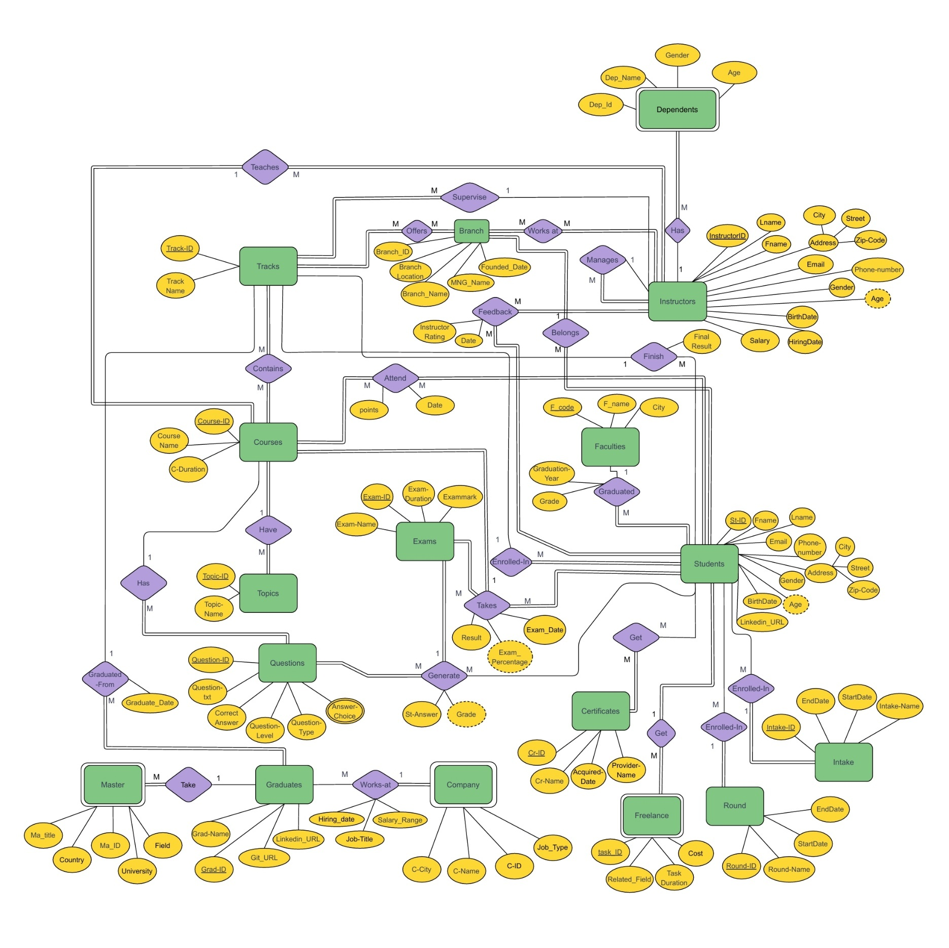

**2.4 Implementation Highlights**

* **Stored Procedures:** Key operations such as exam generation, answer submission, grading, and result computation are encapsulated in stored procedures for performance and security.
* **Indexing:** Indexes are applied to primary and foreign keys and frequently queried fields to optimize data retrieval.
* **Backup & Recovery:** Automated backup schedules and disaster recovery procedures are in place to safeguard data.
* **Extensibility:** The schema is designed for future growth, supporting additional features, reporting, and integration with business intelligence tools.

**2.5 Design Benefits**

This database design ensures that the Examination System can efficiently handle large volumes of data, support complex academic workflows, and provide secure, reliable access to all users. Its structure enables the generation of detailed reports and analytics, empowering ITI staff to make data-driven decisions and maintain high standards of academic integrity.

## Database Diagram

Figure 2: ITI System Database Diagram

This image shows the real structure of tables and their connections in the ITI database system

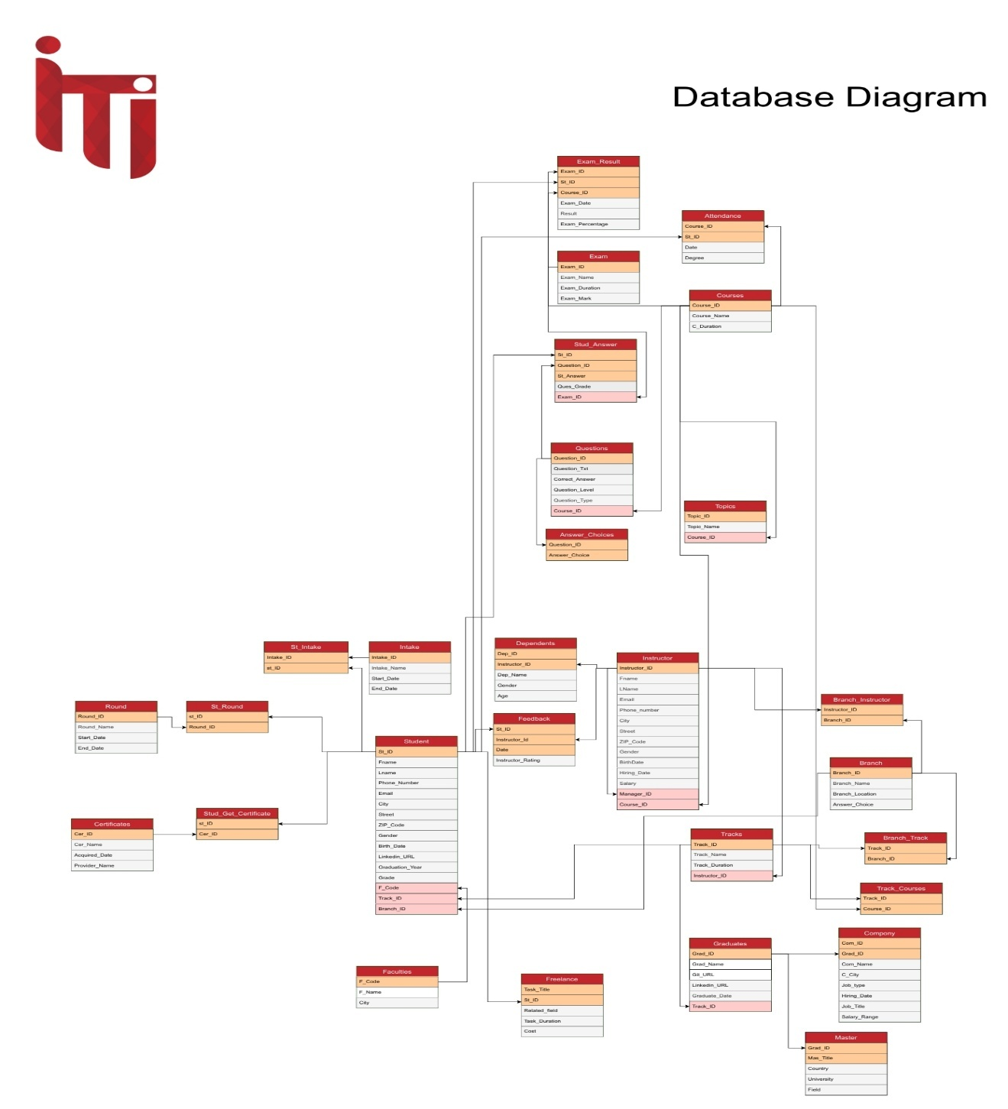

**Figure 2 : DATABASE DIAGRAME**

# Stored Procedures

The Examination System database leverages a set of well-structured stored procedures to manage data operations efficiently and securely. These procedures cover standard CRUD (Create, Read, Update, Delete) operations for all main tables, as well as specialized logic to automate exam workflows. Below is a detailed explanation of both standard and special stored procedures, emphasizing their purpose, logic, and significance.

**1. Standard CRUD Stored Procedures**

For each core table (e.g., Student, Instructor, Course, Exam, Question, Choice, Department, etc.), the following types of stored procedures are implemented:

**a. Insert Procedures**

* **Purpose:** Add new records to the table.
* **Logic:** Accepts parameters for each field, performs input validation, and inserts the record. Returns the new record’s identity value for reference.
* **Example:**

CREATE PROCEDURE sp_InsertStudent  
 @Fname NVARCHAR(50), @Lname NVARCHAR(50), @Track_ID INT, @Branch_ID INT, @Grade DECIMAL(3,2)  
AS  
BEGIN  
 INSERT INTO Student (Fname, Lname, Track_ID, Branch_ID, Grade)  
 VALUES (@Fname, @Lname, @Track_ID, @Branch_ID, @Grade);  
 SELECT SCOPE_IDENTITY() AS NewStudentID;  
END

**b. Select Procedures**

* **Purpose:** Retrieve data, either as full lists or by specific criteria (e.g., by ID, by department).
* **Logic:** Accepts filtering parameters, uses SELECT queries with JOINs where needed, returns requested data.
* **Example:**

CREATE PROCEDURE sp_GetStudentByID  
 @St_ID INT  
AS  
BEGIN  
 SELECT * FROM Student WHERE St_ID = @St_ID;  
END

**c. Update Procedures**

* **Purpose:** Modify existing records.
* **Logic:** Accepts the primary key and fields to update, performs the update, and returns a status or the updated record.
* **Example:**

CREATE PROCEDURE sp_UpdateStudentGrade  
 @St_ID INT, @Grade DECIMAL(3,2)  
AS  
BEGIN  
 UPDATE Student SET Grade = @Grade WHERE St_ID = @St_ID;  
 SELECT * FROM Student WHERE St_ID = @St_ID;  
END

**d. Delete Procedures**

* **Purpose:** Remove records from the table.
* **Logic:** Accepts the primary key, deletes the record, and may return a status or affected rows count.
* **Example:**

CREATE PROCEDURE sp_DeleteStudent  
 @St_ID INT  
AS  
BEGIN  
 DELETE FROM Student WHERE St_ID = @St_ID;  
 SELECT @@ROWCOUNT AS RowsDeleted;  
END

**2. Special Stored Procedures**

These procedures encapsulate more complex business logic, automating key examination workflows.

**2.1 sp_GenerateExamQuestions**

* **Purpose:** Randomly selects a specified number of questions for an exam, filtered by course name.
* **Parameters:**
  + @CourseName (partial or full course name)
  + @QuestionCount (number of questions to select; default is 10)
* **Logic:**
  + Joins Questions and Courses tables.
  + Filters questions by course name using a LIKE clause.
  + Uses ORDER BY NEWID() to randomize selection, ensuring each exam is unique.
  + Returns question details: ID, text, correct answer, level, and type.
* **Significance:**
  + Ensures fairness and unpredictability in exams.
  + Supports dynamic exam generation for each student/session.

**2.2 sp_InsertStudentAnswer**

* **Purpose:** Records a student's answer to a specific question in an exam.
* **Parameters:**
  + @St_ID, @Question_ID, @St_Answer, @Exam_ID
* **Logic:**
  + Inserts the answer into Stud_answers with an initial grade of 0 (pending correction).
  + Returns the new answer’s identity value.
* **Significance:**
  + Captures student responses securely and immediately.
  + Prepares data for automated grading.

**2.3 sp_CorrectAnswersAndUpdateGrades**

* **Purpose:** Grades all answers submitted by a student for a specific exam and calculates performance.
* **Parameters:**
  + @St_ID, @Exam_ID
* **Logic:**
  + Updates Ques_Grade in Stud_answers to 10 if the answer matches the correct answer, 0 otherwise.
  + Counts total questions and correct answers.
  + Calculates the percentage score.
  + Returns total questions, correct answers, and percentage.
* **Significance:**
  + Automates objective grading, ensuring consistency and speed.
  + Provides instant feedback on performance.
  + Reduces instructor workload and human error.

**2.4 sp_InsertExamResult**

* **Purpose:** Records the final exam result for a student, including pass/fail status.
* **Parameters:**
  + @St_ID, @Exam_ID, @Course_ID, @Exam_Percentage
* **Logic:**
  + Determines pass/fail based on a 60% threshold.
  + Inserts the result into Exam_Result with a timestamp.
  + Returns the percentage and result status.
* **Significance:**
  + Centralizes result management.
  + Enables immediate result communication to students.

**2.5 sp_GetAnswerChoices**

* **Purpose:** Retrieves all possible answer choices for a given question.
* **Parameters:**
  + @Question_ID
* **Logic:**
  + Selects all choices from Answer_Choices for the specified question.
* **Significance:**
  + Supports the exam interface in displaying multiple-choice options.
  + Ensures that students see all valid choices for each question.

**3. Summary Table: Key Stored Procedures**

|  |  |  |
| --- | --- | --- |
| Procedure Name | Main Function | Key Tables Affected |
| sp_Insert[Entity] | Insert new records | All core tables |
| sp_Select[Entity] | Retrieve records (by ID or criteria) | All core tables |
| sp_Update[Entity] | Update existing records | All core tables |
| sp_Delete[Entity] | Delete records | All core tables |
| sp_GenerateExamQuestions | Random exam question selection | Questions, Courses |
| sp_InsertStudentAnswer | Record student answers | Stud_answers |
| sp_CorrectAnswersAndUpdateGrades | Automated grading and performance calculation | Stud_answers, Questions |
| sp_InsertExamResult | Store exam results and pass/fail status | Exam_Result |
| sp_GetAnswerChoices | Retrieve answer choices for a question | Answer_Choices |

**4. Best Practices Reflected**

* **Parameterization:** All procedures use parameters to prevent SQL injection and enforce data validation.
* **Transaction Control:** Critical operations (especially updates and inserts) can be wrapped in transactions for atomicity and rollback support.
* **Scalability:** Modular procedures enable easy maintenance and extension.
* **Security:** Role-based execution permissions restrict access to sensitive operations.

These stored procedures form the backbone of the Examination System’s data management and exam automation, ensuring reliability, security, and efficiency throughout the academic workflow.

## Data Warehouse Design

Introduction: Why Do We Need to Transform Data into a Data Warehouse?

As part of the ITI Graduation Project, our goal is to build a robust Data Warehouse solution that enables better data management, reporting, and decision-making.

In today’s data-driven world, organizations generate vast amounts of data from various sources — such as operational systems, logs, transactions, and user interactions. However, this raw data is often inconsistent, fragmented, and not optimized for analysis.

A **Galaxy Schema** was designed to support complex analysis, using multiple fact tables and shared dimension tables. This schema allows flexibility and efficiency in reporting.

The Data Warehouse component of the Examination System is designed to support advanced analytics, historical tracking, and comprehensive reporting for institutional decision-making. It extends the operational database by integrating, transforming, and storing data in a format optimized for analysis and business intelligence.

**4.1 Purpose and Benefits**

* **Historical Analysis:** Enables tracking of academic performance, exam results, and student progression over time.
* **Aggregated Reporting:** Supports complex queries and dashboards that would be resource-intensive on the transactional database.
* **Decision Support:** Provides ITI staff, administrators, and instructors with actionable insights for curriculum planning, resource allocation, and student support.
* **Data Consistency:** Ensures a single source of truth for all analytics and institutional reporting.

**4.2 Architecture Overview**

* **ETL Processes:** Data is extracted from the database, transformed (cleaned, aggregated, and restructured), and loaded into the Data Warehouse. ETL is typically automated using tools like SQL Server Integration Services (SSIS).
* **Star Schema Design:** The warehouse uses a star schema for efficient querying, with fact tables capturing measurable events (e.g., exam results, attendance) and dimension tables providing descriptive context (e.g., student, course, instructor).
* **Batch Updates:** Data is refreshed on a scheduled basis (e.g., nightly) to ensure up-to-date analytics without impacting the performance of the operational system.

**4.3 Main Components**

**Fact Tables**

* **Fact_Exam_Result:** Stores exam scores, percentages, pass/fail status, and links to related dimensions (student, exam, course, date).
* **Fact_Student_Finish:** Tracks student completion metrics, graduation status, and related outcomes.
* **Fact_Attendance:** Records attendance events, linking students, courses, and dates.

**Dimension Tables**

* **Dim_Student:** Contains student attributes (ID, name, track, branch, intake, etc.).
* **Dim_Course:** Details about courses (ID, name, duration, department).
* **Dim_Instructor:** Instructor information (ID, name, email, salary, specialization).
* **Dim_Exam:** Exam metadata (ID, name, duration, total marks).
* **Dim_Branch, Dim_Track, Dim_Graduate, Dim_Feedback, Dim_Date:** Additional context for analytics and drill-down reporting.

**4.4 ETL and Data Flow**

1. **Extraction:** Data is regularly pulled from the OLTP system, including new exams, student records, answers, and results.
2. **Transformation:** Data is cleaned (duplicates removed, formats standardized), aggregated (e.g., total scores, average grades), and enriched (e.g., joining with dimension data).
3. **Loading:** Transformed data is loaded into the warehouse’s fact and dimension tables, ready for analysis.

**4.5 Reporting and Analytics**

* **Power BI Dashboards:** Visualize trends in student performance, instructor effectiveness, course outcomes, and graduate employment.
* **SSRS/Crystal Reports:** Generate parameterized and ad-hoc reports for academic review, accreditation, and internal audits.
* **Advanced Analytics:** Supports predictive modeling, cohort analysis, and drill-downs by department, course, or instructor.

**4.6 Security and Maintenance**

* **Access Control:** Only authorized users can access sensitive analytics and reports.
* **Data Refresh Scheduling:** ETL jobs are scheduled during off-peak hours to minimize operational impact.
* **Backup and Recovery:** Regular backups ensure data warehouse integrity and business continuity.

The Data Warehouse is a critical extension of the Examination System, enabling robust analytics and reporting capabilities that drive academic excellence and informed decision-making across the institution.

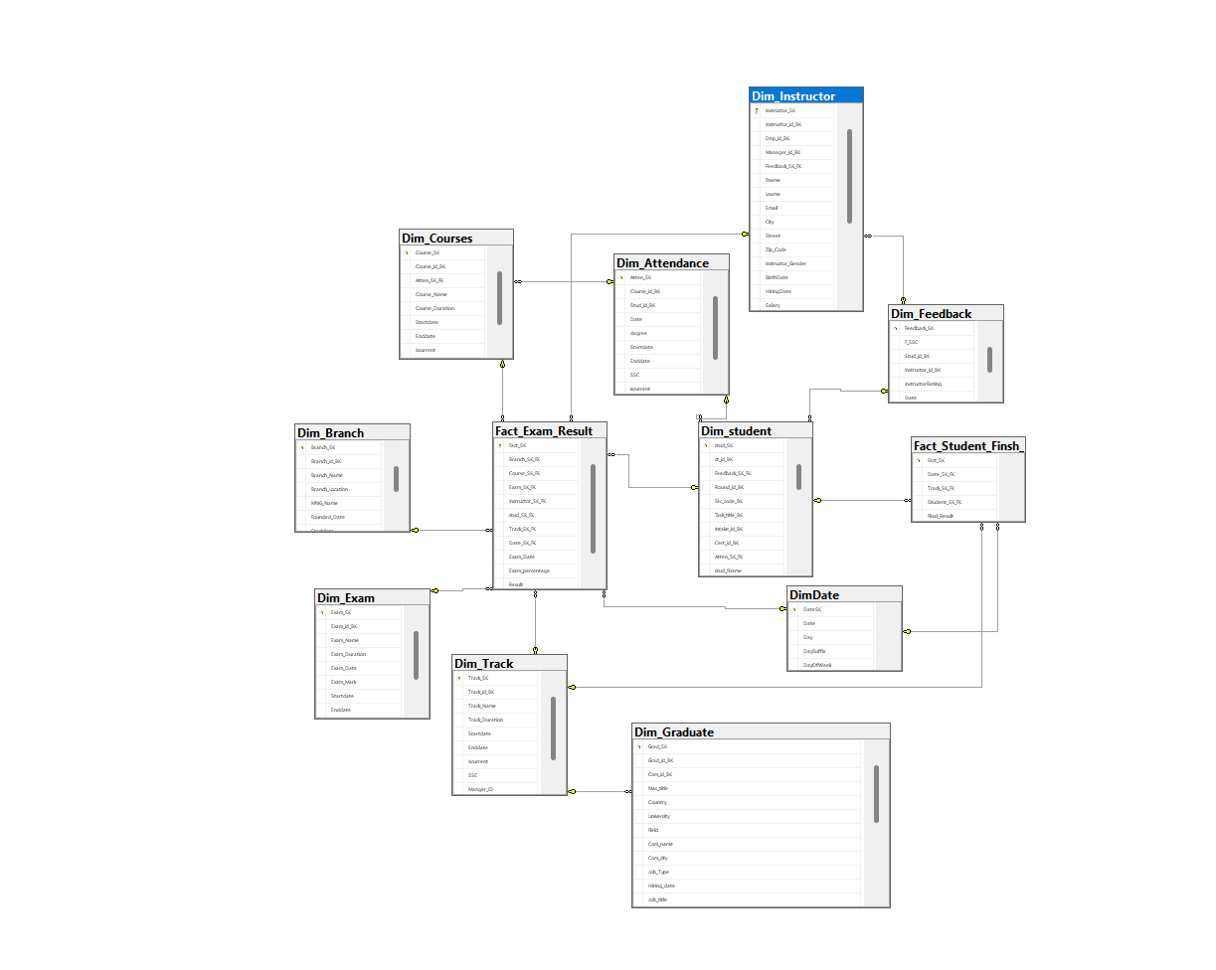

## ETL Process in DWH

The ETL (Extract, Transform, Load) process is the backbone of the Data Warehouse (DWH) in the Examination System. It ensures that data from the operational database is systematically extracted, transformed, and loaded into the DWH, supporting advanced analytics and reporting. Each SSIS (SQL Server Integration Services) package is designed for a specific dimension or fact table, automating the flow and transformation of data.

Below are detailed explanations for each of the 11 ETL packages, which correspond to the images you will include in your report.

* 1. **Dim_Student**

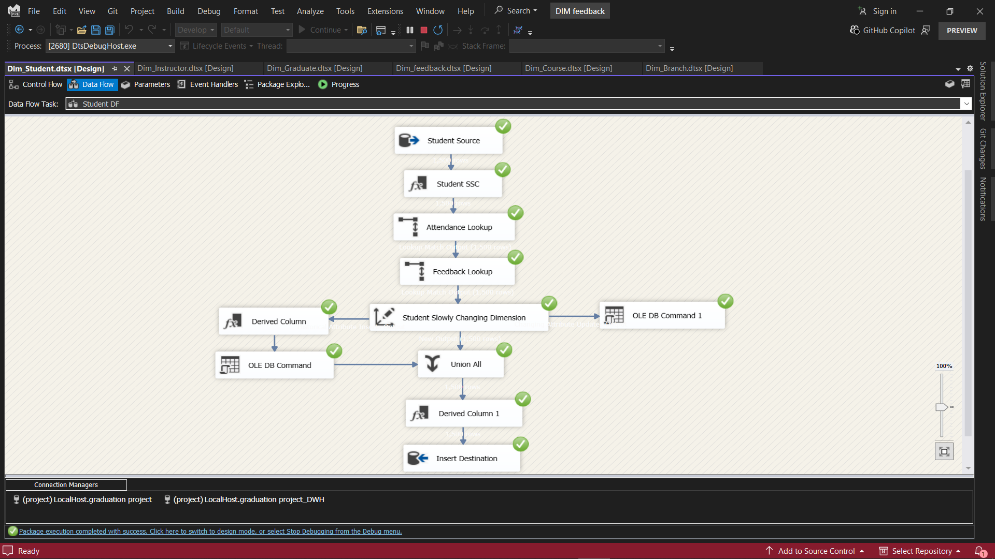

**Purpose:**  
Populates the Student dimension in the DWH with enriched student attributes such as name, track, branch, intake, and graduation status.

**Key Steps:**

* Extracts student data from the OLTP database.
* Performs lookups to resolve foreign keys (e.g., track, branch).
* Handles Slowly Changing Dimension (SCD) logic to track changes over time.
* Loads the cleaned and enriched data into Dim_Student in the DWH.
  1. **Dim_Instructor**

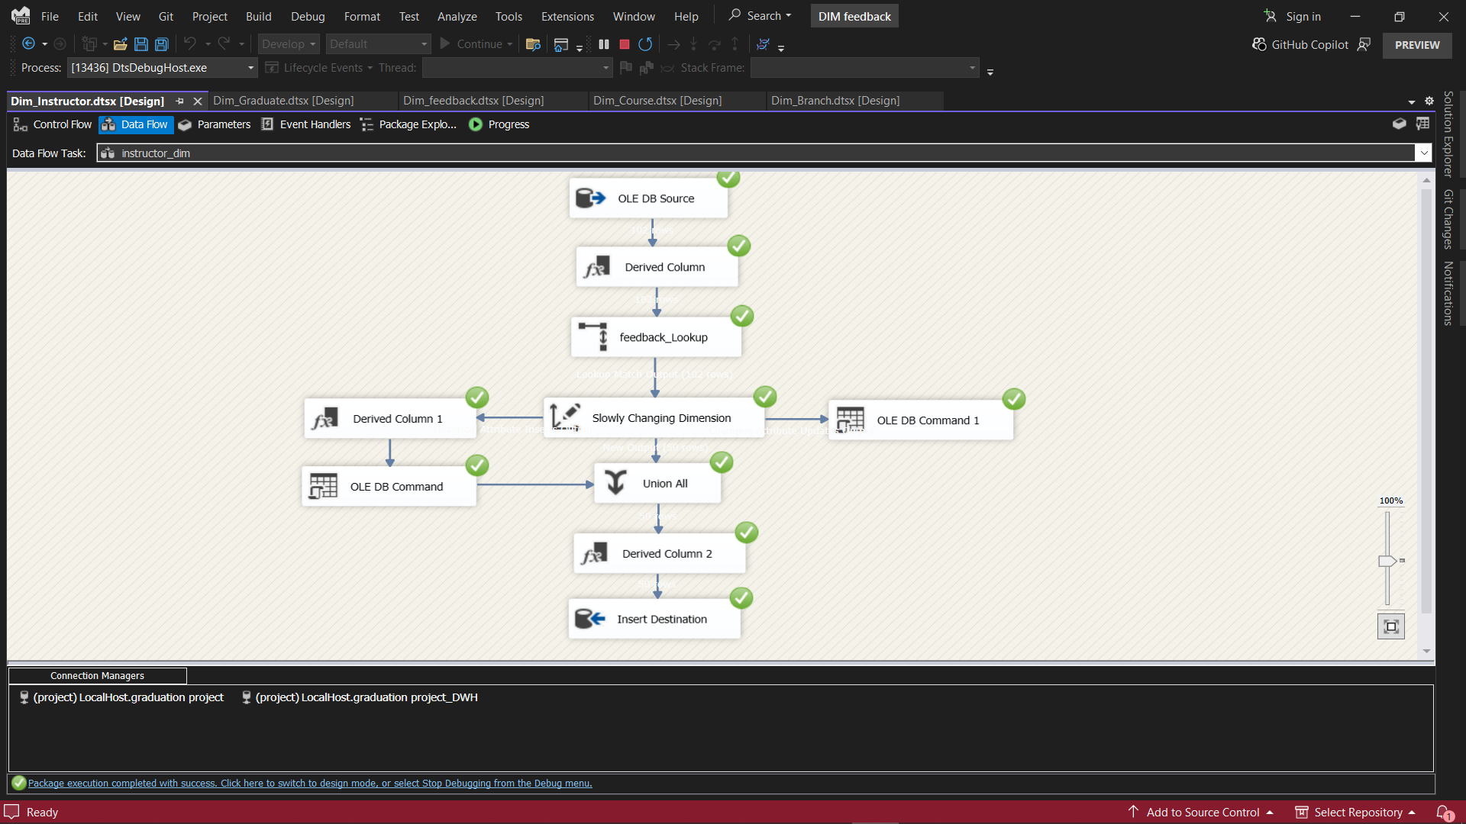

**Purpose:**  
Loads instructor details into the Instructor dimension, capturing attributes like name, email, salary, and specialization.

**Key Steps:**

* Extracts instructor data from the source.
* Applies data transformations (e.g., formatting names, standardizing emails).
* Resolves department and branch relationships via lookups.
* Loads the data into Dim_Instructor.
  1. **Dim_Course**

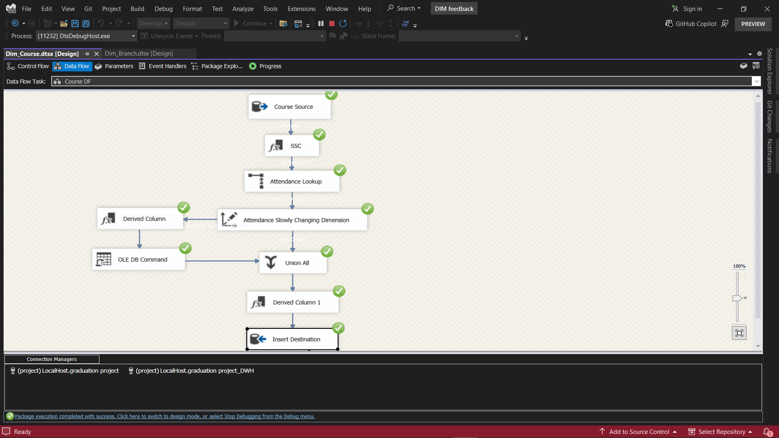

**Purpose:**  
Populates the Course dimension with course metadata, including course name, duration, and department association.

**Key Steps:**

* Extracts course information from the OLTP system.
* Performs lookups for department and topic associations.
* Cleans and standardizes course names and codes.
* Loads the processed data into Dim_Course.
  1. **Dim_Branch**

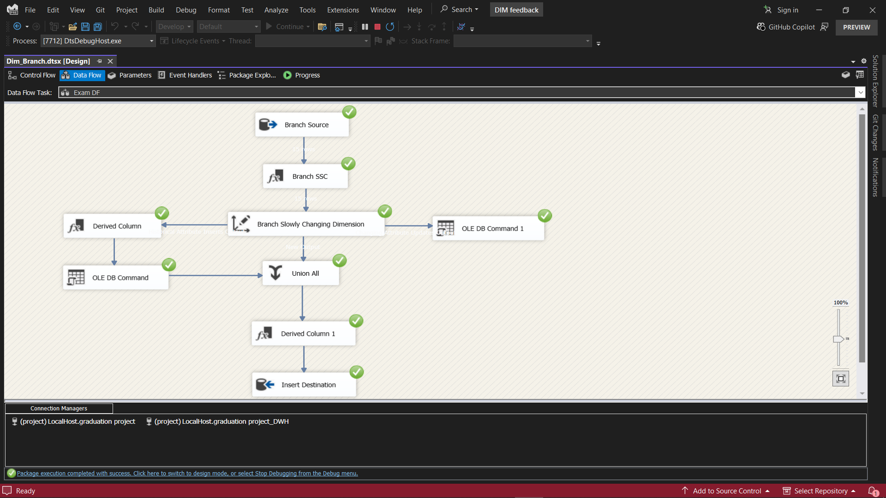

**Purpose:**  
Loads branch information into the DWH, supporting analysis by location or branch.

**Key Steps:**

* Extracts branch data (name, location) from the source.
* Standardizes location data for consistency.
* Loads the data into Dim_Branch.

1. **Dim_Track**

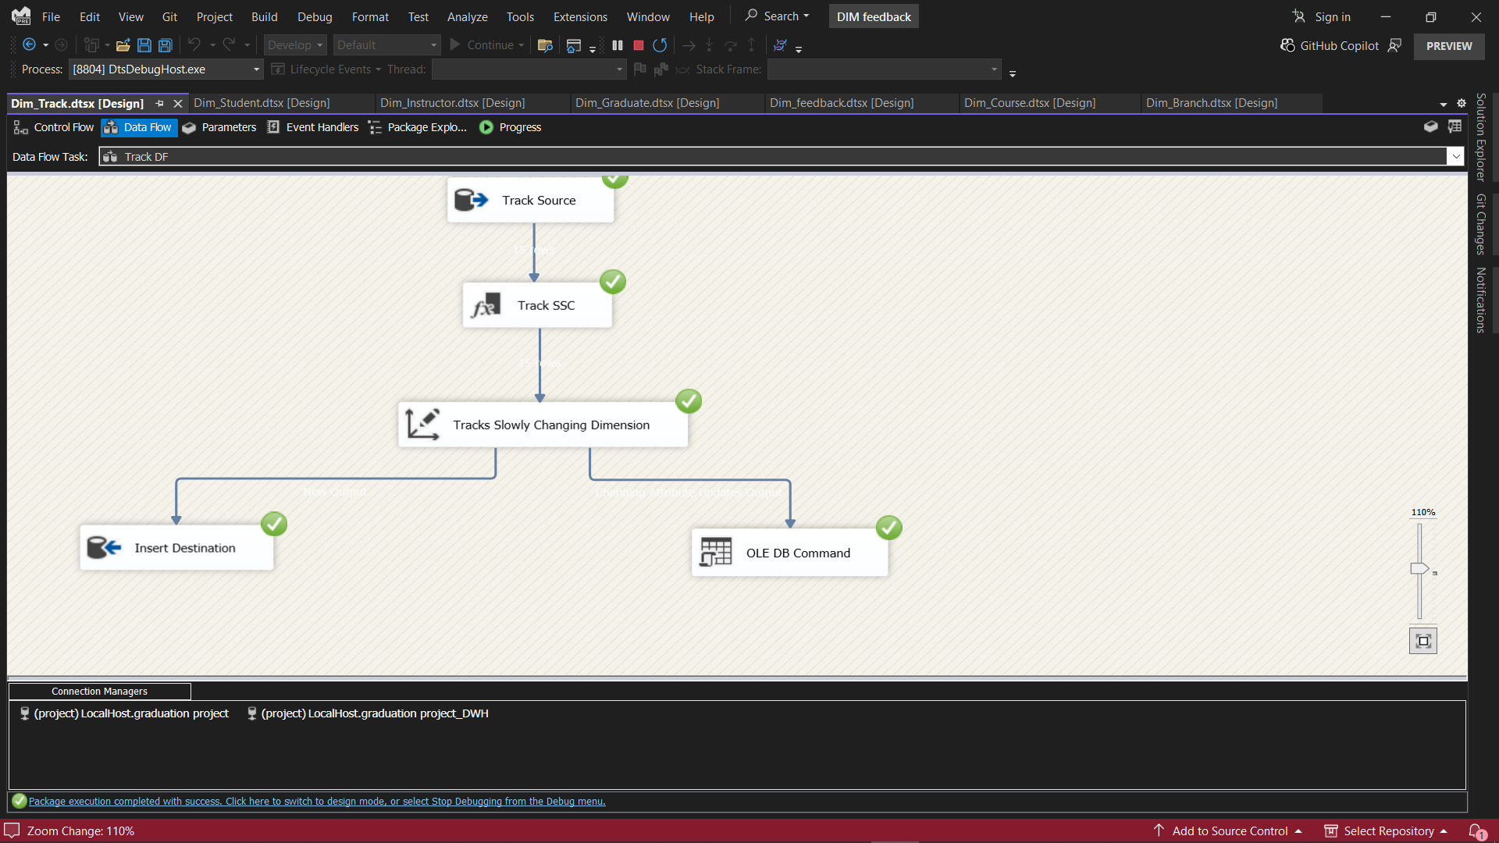

**Purpose:**  
Populates the Track dimension with academic track details.

**Key Steps:**

* Extracts track names and durations.
* Cleans and formats track data.
* Loads the data into Dim_Track.
  1. **Dim_Graduate**

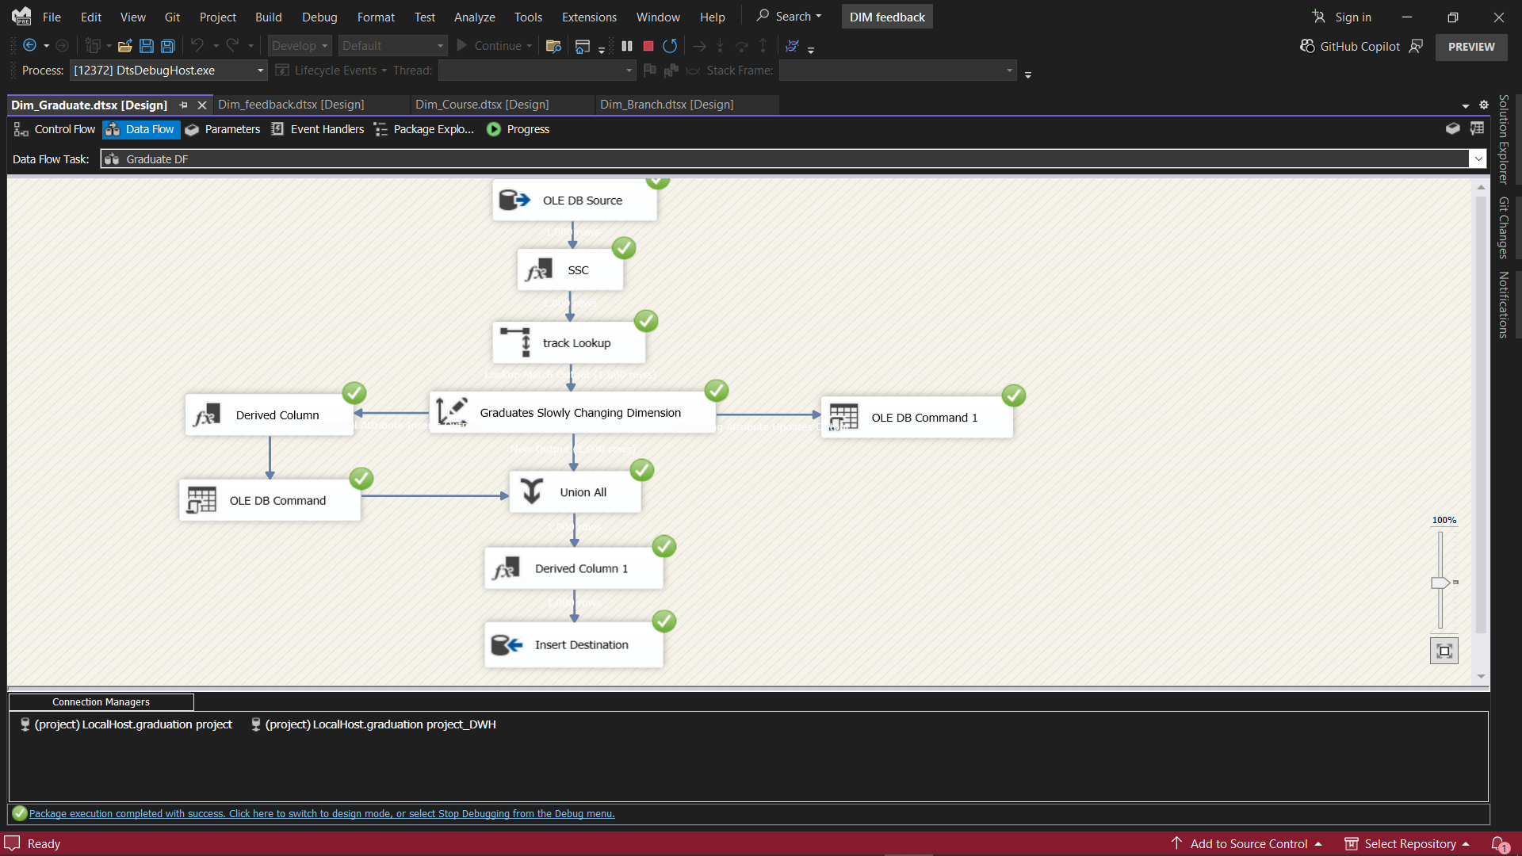

**Purpose:**  
Captures graduate records, including employment and postgraduate details.

**Key Steps:**

* Extracts graduate data (names, GitHub/LinkedIn URLs).
* Joins with employment and certificate data for enrichment.
* Loads the data into Dim_Graduate.
  1. **Dim_Feedback**

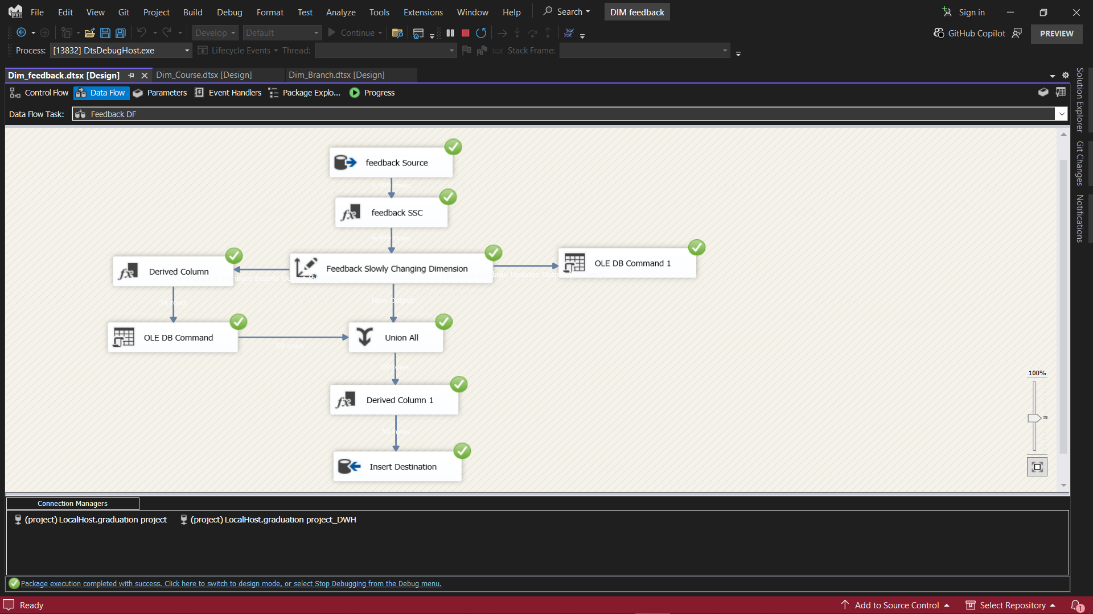

**Purpose:**  
Loads student feedback for instructors, supporting analytics on teaching quality.

**Key Steps:**

* Extracts feedback records (student ID, instructor ID, rating, date).
* Resolves student and instructor references.
* Loads the data into Dim_Feedback.

1. **Dim_Attendance**

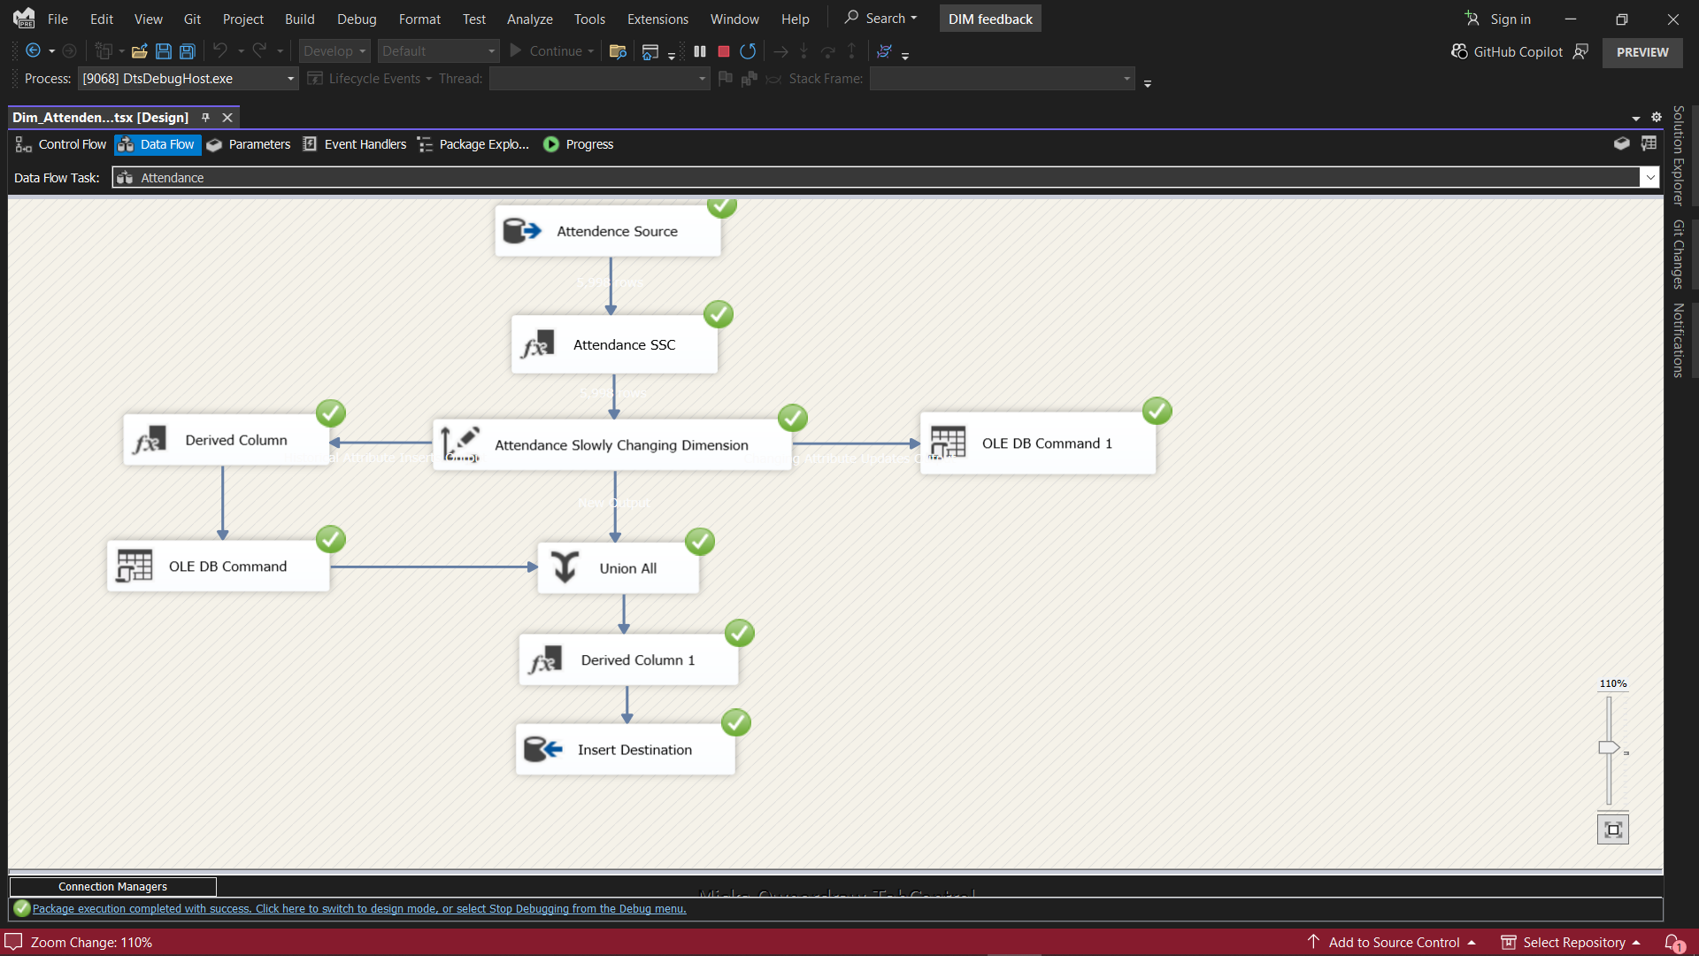

**Purpose:**  
Populates the Attendance dimension for tracking student participation.

**Key Steps:**

* Extracts attendance events (student, course, date, degree).
* Performs lookups for student and course references.
* Loads the data into Dim_Attendance.

1. **Dim_Exam**

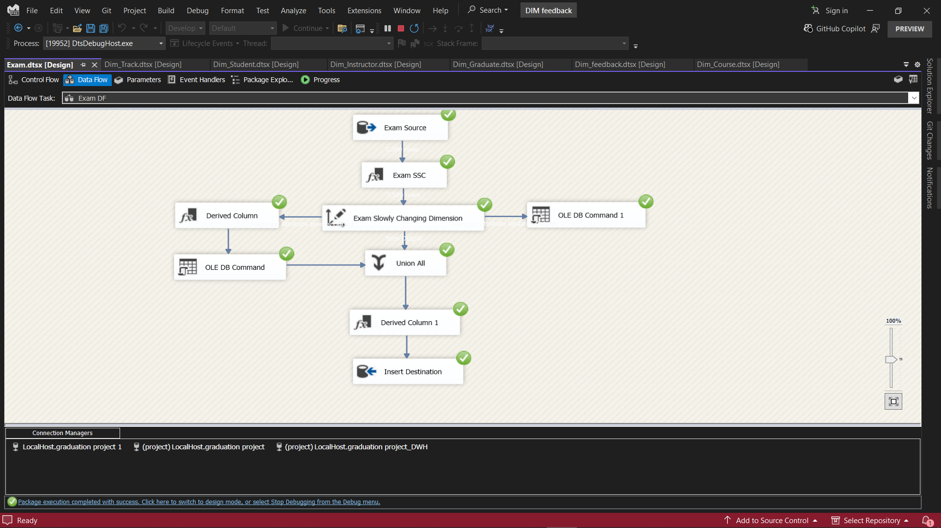

**Purpose:**  
Populates the Exam dimension with exam metadata.

**Key Steps:**

* Extracts exam data (exam ID, name, duration, total marks).
* Joins with course and instructor data for context.
* Loads the data into Dim_Exam.

1. **Fact_Exam_Result**

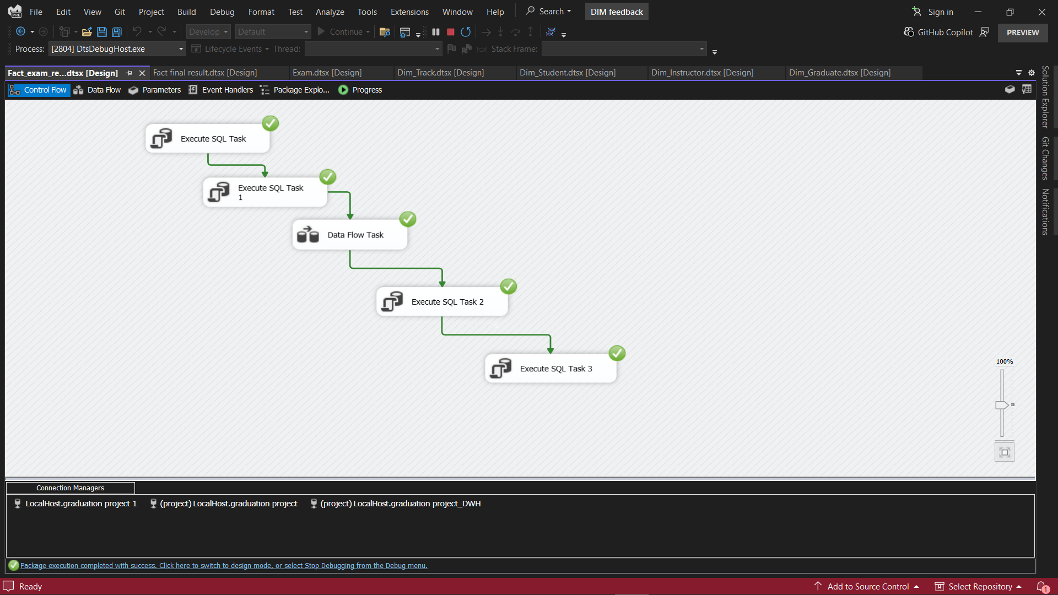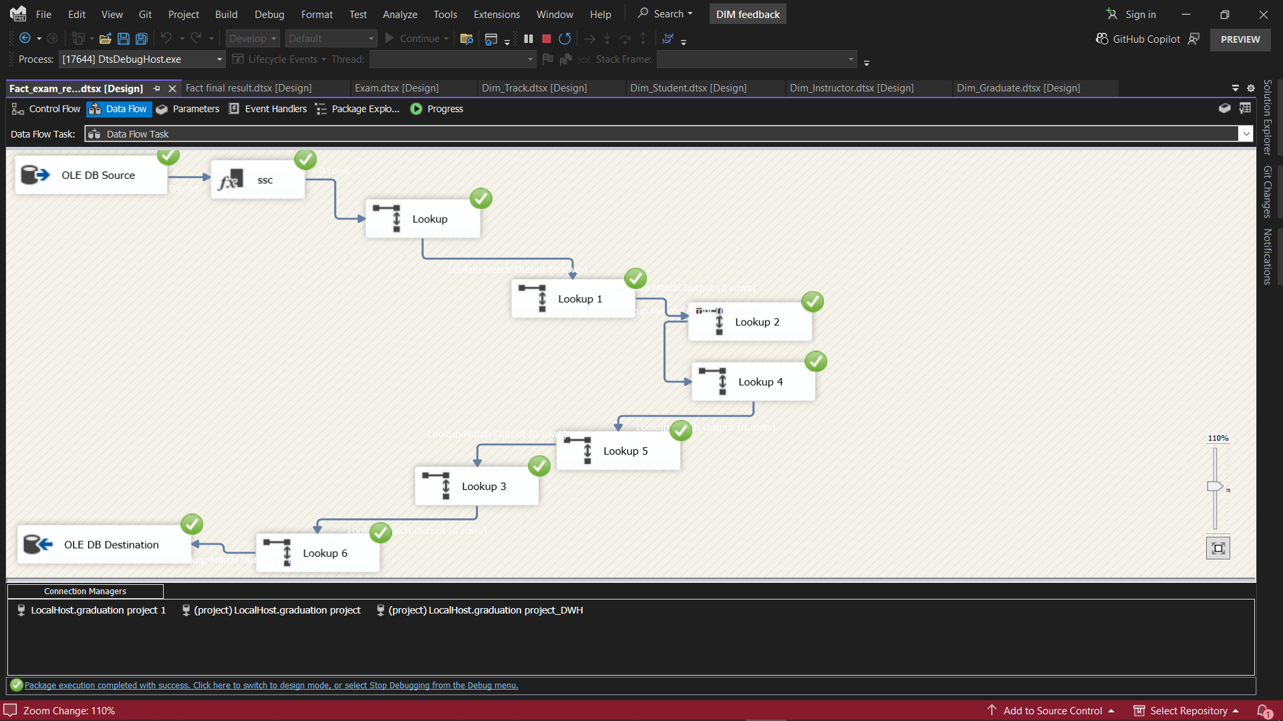

**Purpose:**  
Loads exam results into the fact table, supporting performance analytics.

**Key Steps:**

* Extracts exam result records (student ID, exam ID, score, percentage, pass/fail).
* Resolves dimension keys (student, exam, course).
* Loads the data into Fact_Exam_Result.

1. **Fact_Final_Result**

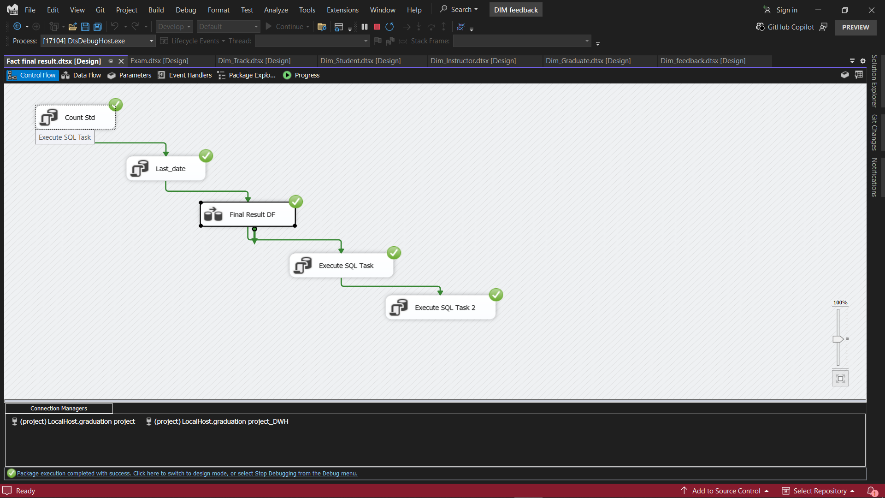

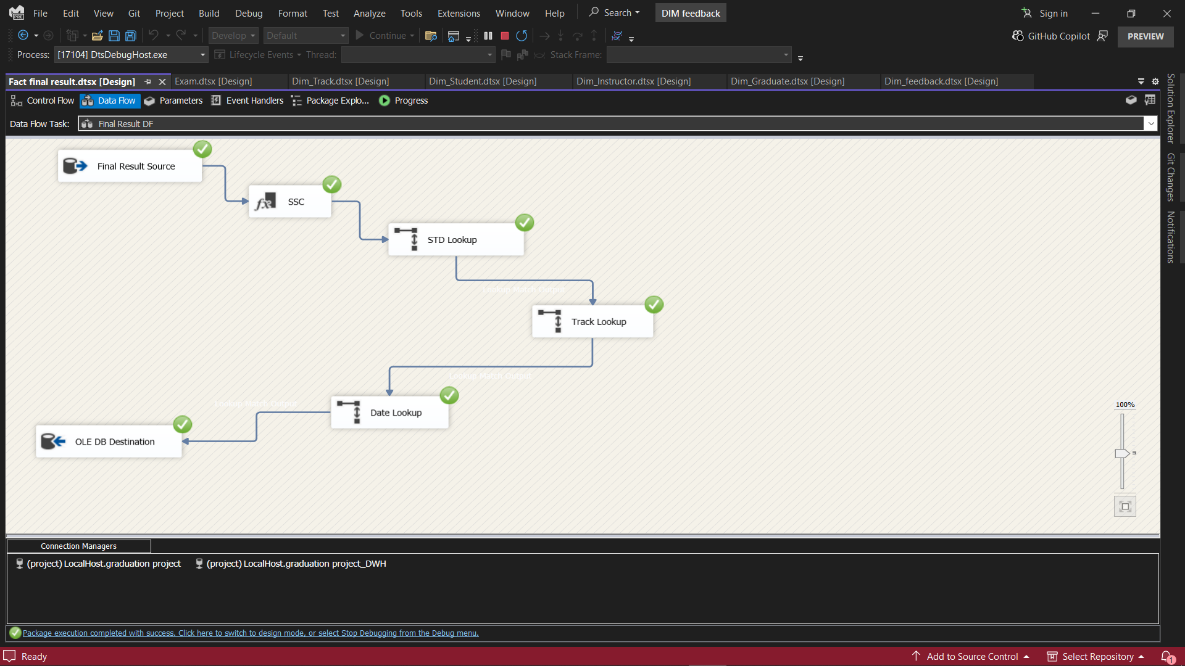

**Purpose:**  
Captures final results for students, enabling graduation and outcome analysis.

**Key Steps:**

* Extracts final grades and completion status.
* Aggregates results across courses and exams.
* Loads the data into Fact_Final_Result.

**ETL Process Summary Table**

|  |  |  |
| --- | --- | --- |
| Package Name | Main Function | Data Target |
| Dim_Student.dtsx | Student dimension population | DWH.Dim_Student |
| Dim_Instructor.dtsx | Instructor dimension population | DWH.Dim_Instructor |
| Dim_Course.dtsx | Course dimension population | DWH.Dim_Course |
| Dim_Branch.dtsx | Branch dimension population | DWH.Dim_Branch |
| Dim_Track.dtsx | Track dimension population | DWH.Dim_Track |
| Dim_Graduate.dtsx | Graduate dimension population | DWH.Dim_Graduate |
| Dim_Feedback.dtsx | Feedback dimension population | DWH.Dim_Feedback |
| Dim_Attendance.dtsx | Attendance dimension population | DWH.Dim_Attendance |
| Dim_Exam.dtsx | Exam dimension population | DWH.Dim_Exam |
| Fact_Exam_Result.dtsx | Exam results fact table population | DWH.Fact_Exam_Result |
| Fact_Final_Result.dtsx | Final results fact table population | DWH.Fact_Final_Result |

Each ETL package is designed to ensure data quality, consistency, and readiness for business intelligence and reporting. The images you include in your report should visually illustrate the control flow, data flow, and key transformations described above, providing clear documentation of your ETL architecture and implementation.

## SSRS Reports

The Examination System leverages SQL Server Reporting Services (SSRS) to deliver dynamic, parameterized, and visually rich reports for academic management and decision-making. These reports are directly powered by stored procedures and data warehouse views, ensuring real-time, reliable insights for ITI staff, instructors, and students.

**7.1 Overview of SSRS Reports**

SSRS is used to create, deploy, and manage a suite of reports that address the core operational and analytical needs of the institution. Reports are designed to be interactive, exportable (PDF, Excel, etc.), and accessible through a web portal or integrated application interface.

**7.2 Key Reports Implemented**

**1. Students Information by Department**

* **Purpose:** Lists all students in a selected department.
* **Parameters:** Department Number.
* **Features:** Displays student ID, full name, contact details, address, gender, birth date, LinkedIn URL, graduation year, grade, and department information.
* **Sample Output:**

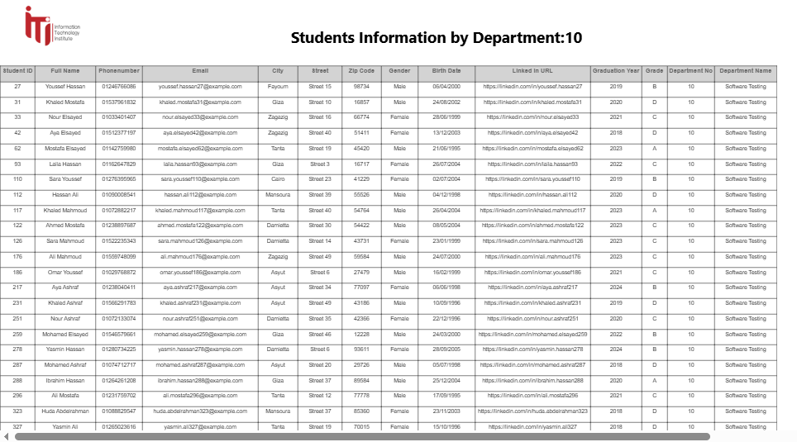

**2. Student Grades in All Courses**

* **Purpose:** Shows the grades of a specific student across all enrolled courses.
* **Parameters:** Student ID.
* **Features:** Displays course names and grade percentages for the student.
* **Sample Output:**

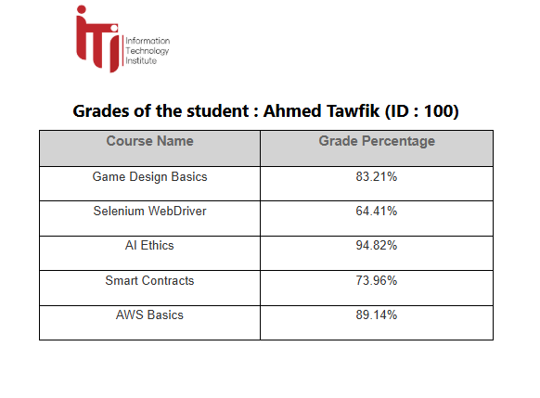

**3. Instructor’s Courses and Student Count**

* **Purpose:** Lists all courses taught by a particular instructor and the number of students enrolled in each.
* **Parameters:** Instructor ID.
* **Features:** Facilitates workload analysis and resource planning.
* **Sample Output:**

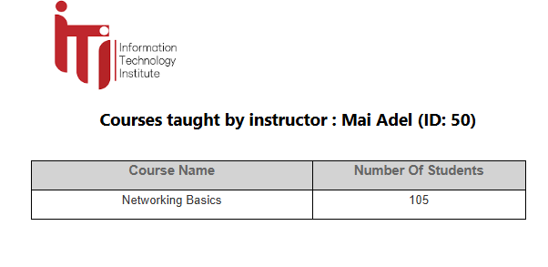4. Course Topics

* **Purpose:** Displays all topics covered within a selected course.
* **Parameters:** Course ID.
* **Features:** Useful for curriculum review and planning.

**Sample Output:**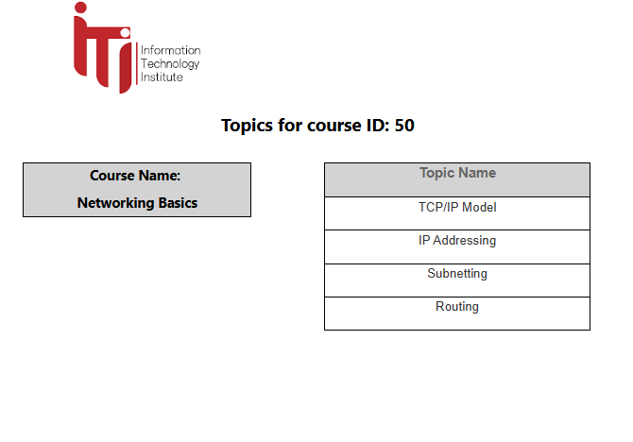

**5. Exam Questions and Choices**

* **Purpose:** Retrieves all questions and corresponding answer choices for a specific exam.
* **Parameters:** Exam Number.
* **Features:** Supports exam review and quality assurance.
* **Sample Output:**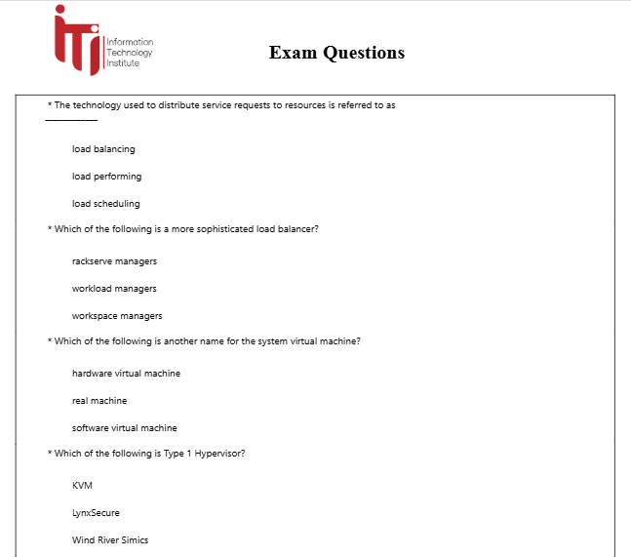

**6. Exam Questions with Student Answers**

* **Purpose:** Shows all questions in a specific exam along with the answers given by a particular student and the grade for each answer.
* **Parameters:** Exam Number, Student ID.
* **Features:** Enables detailed review of student performance and grading transparency.
* **Sample Output:**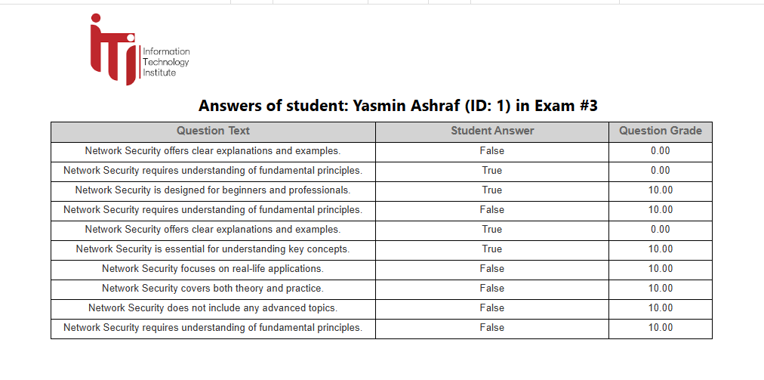

**7.3 SSRS Report Features**

* **Parameterization:** Users can filter reports by department, student, instructor, course, or exam.
* **Interactivity:** Drill-down and drill-through capabilities allow users to explore data in detail.
* **Export Options:** Reports can be exported to PDF, Excel, Word, and other formats for sharing and archiving.
* **Security:** Access to reports is controlled based on user roles, ensuring data privacy and compliance.

**7.4 Integration with Data Warehouse**

* **Live Data:** Reports are powered by up-to-date data from the operational database and the data warehouse.
* **Historical Analysis:** Some reports leverage fact and dimension tables in the DWH for trend and cohort analysis.
* **Performance:** SSRS is optimized for efficient querying and rendering, even with large datasets.

**7.5 Benefits**

* **Informed Decision-Making:** Provides ITI staff and instructors with actionable insights.
* **Transparency:** Enhances trust by making grading and academic records accessible and auditable.
* **Efficiency:** Reduces manual reporting workload and eliminates errors.
* **Scalability:** Easily accommodates new report types and data sources as the system grows.

These SSRS reports are central to the Examination System’s value, transforming raw academic data into meaningful, actionable information for all stakeholders.

## Power BI Dashboards

20+ dashboards were developed to provide interactive analytics. Highlights include

## Introductory Pages

* Dashboard 1: System Welcome Page
* Introduces users to the dashboard system and its purpose. Explains the platform structure, who can access what, and how to use it.
* Dashboard 2: Role-Based Access Overview

Clarifies what students, instructors, and ITI management can view. Table of permissions, navigation tips, and expected use.

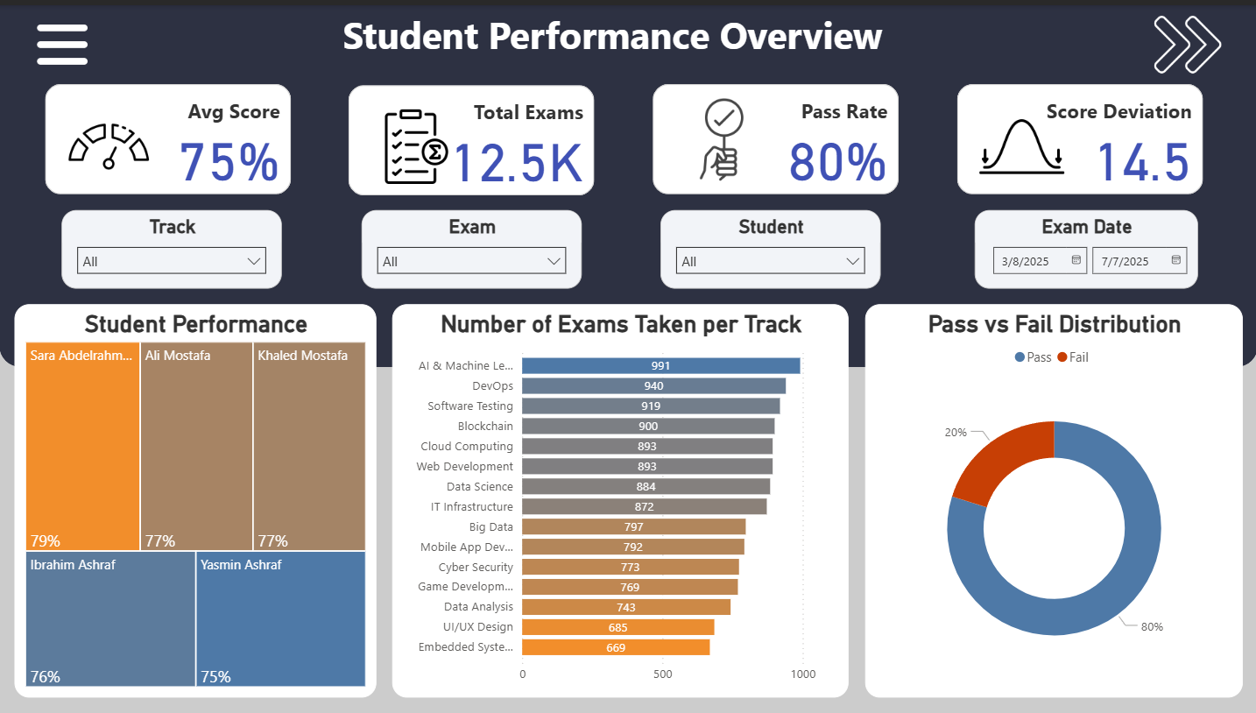

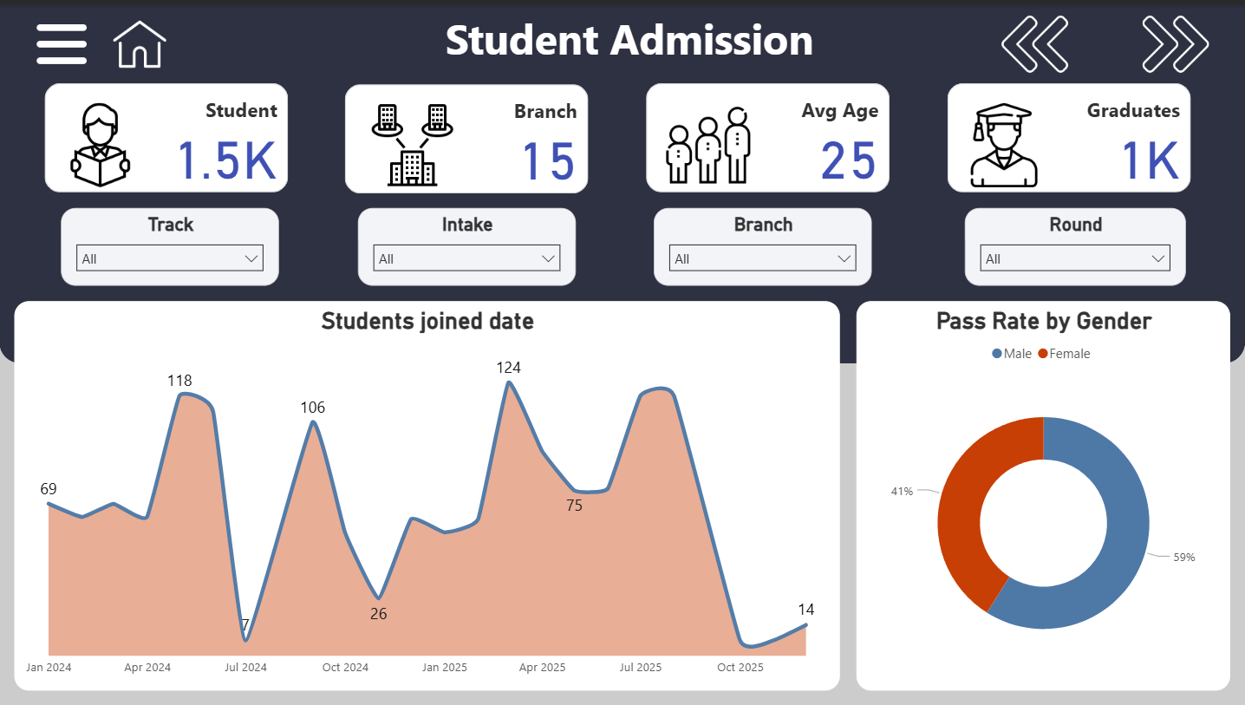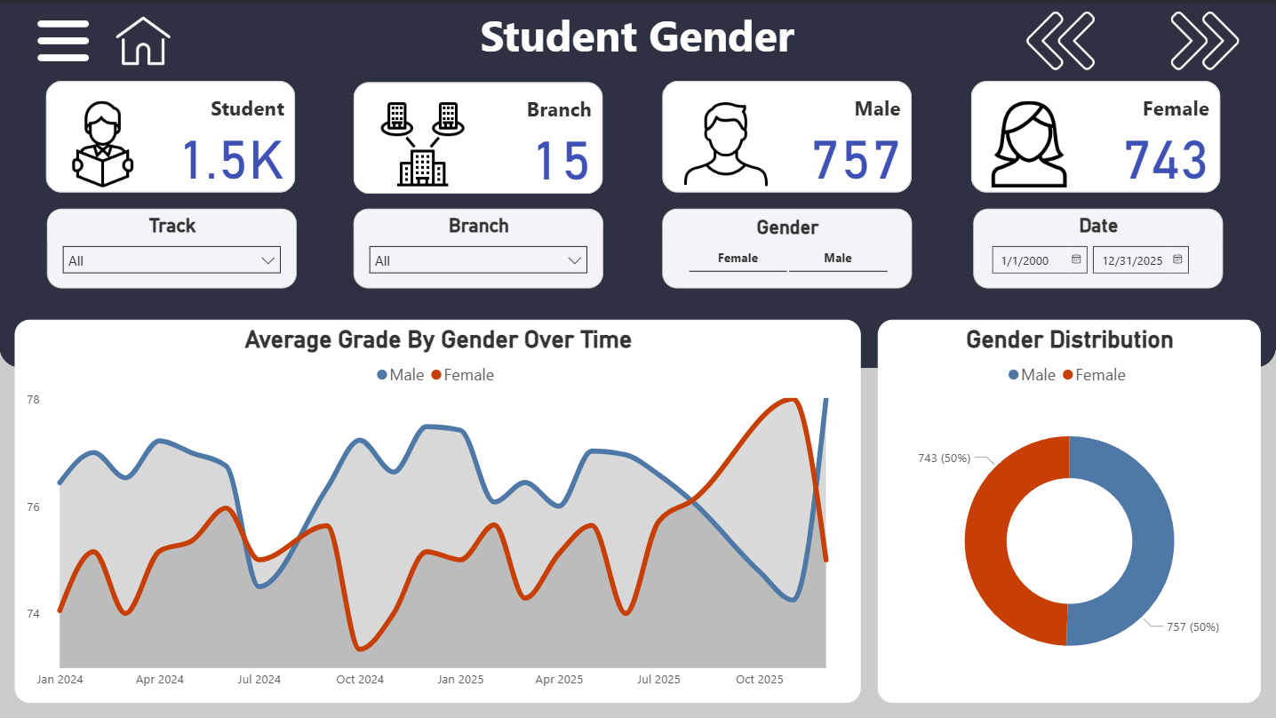

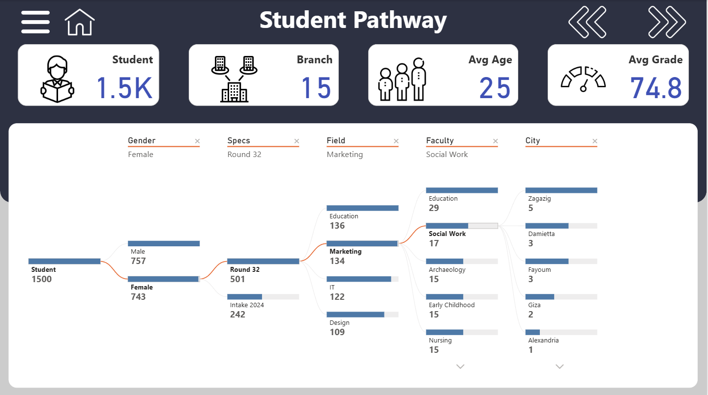

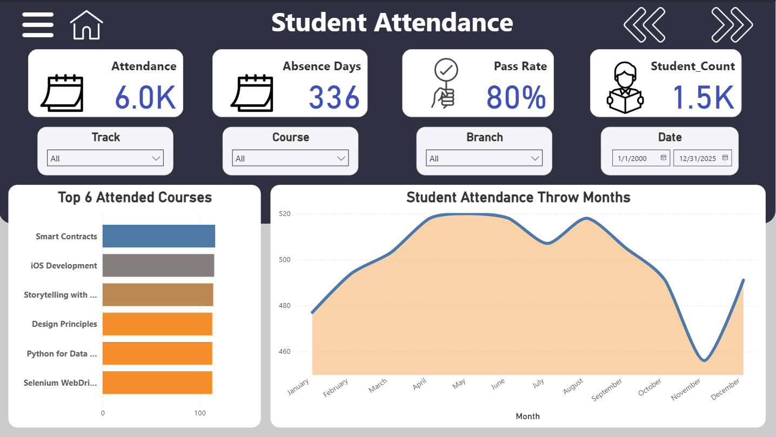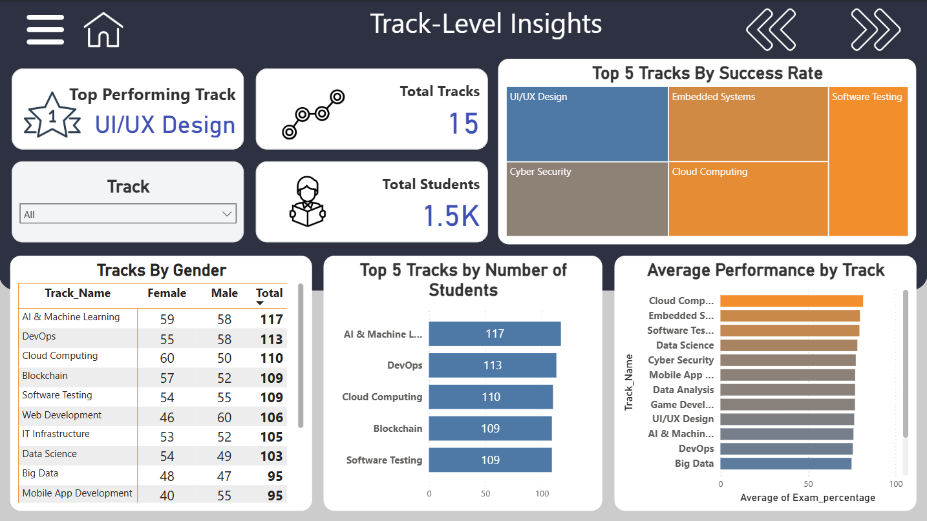

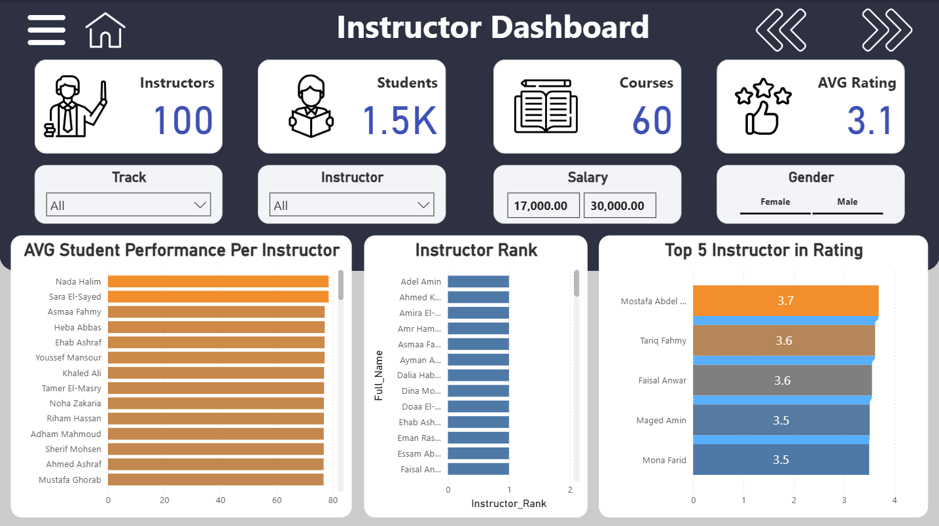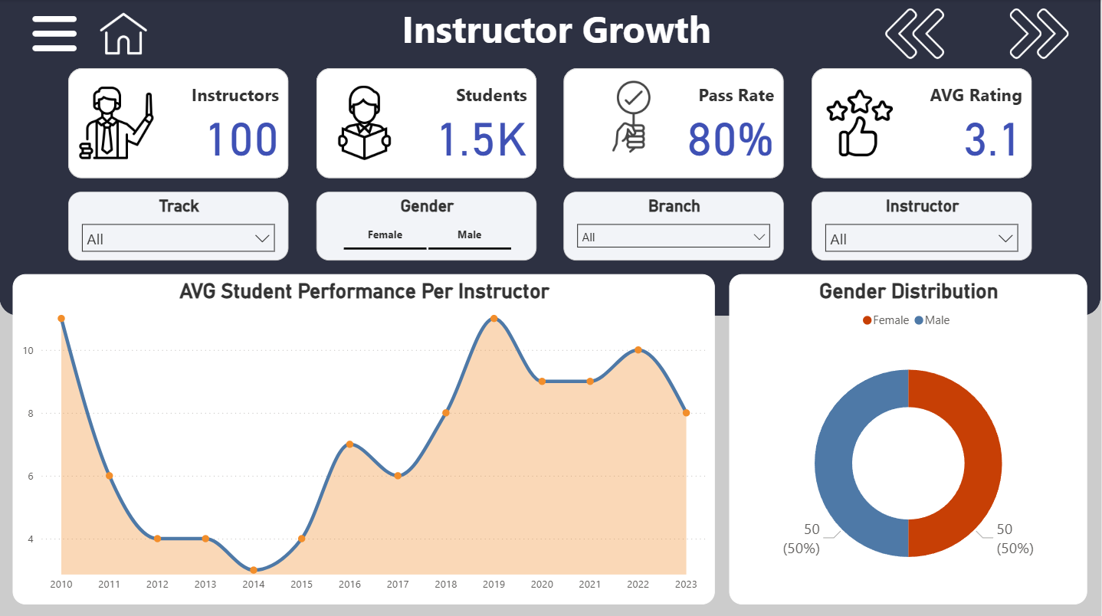

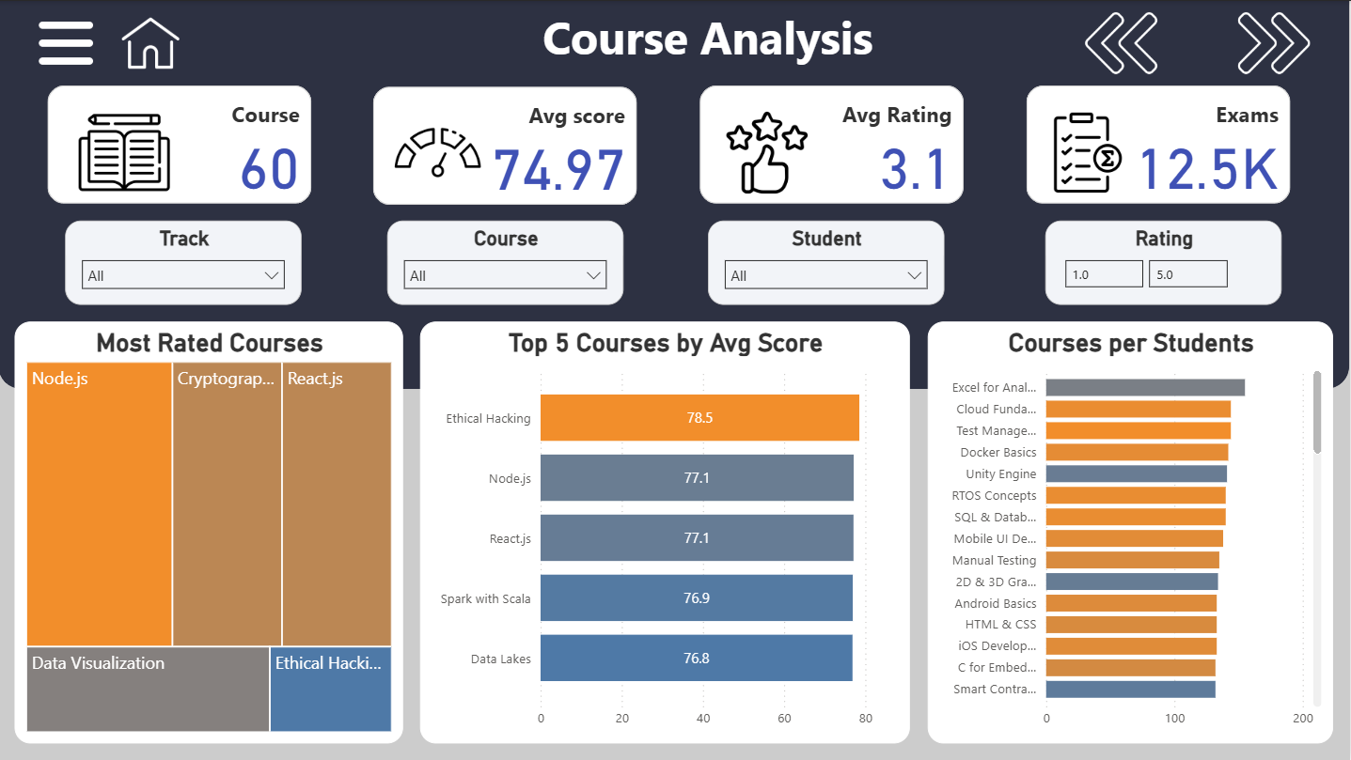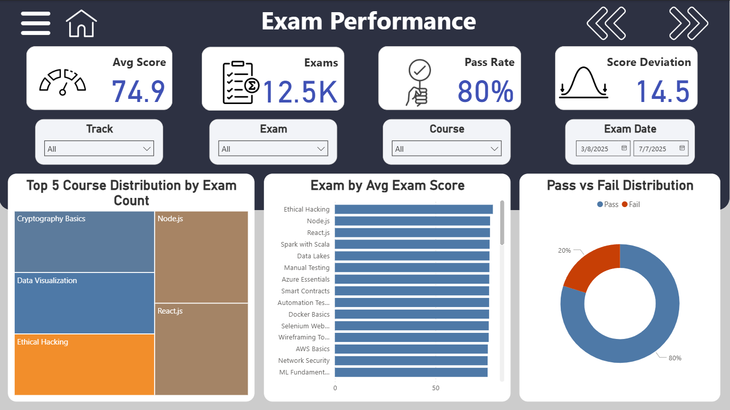

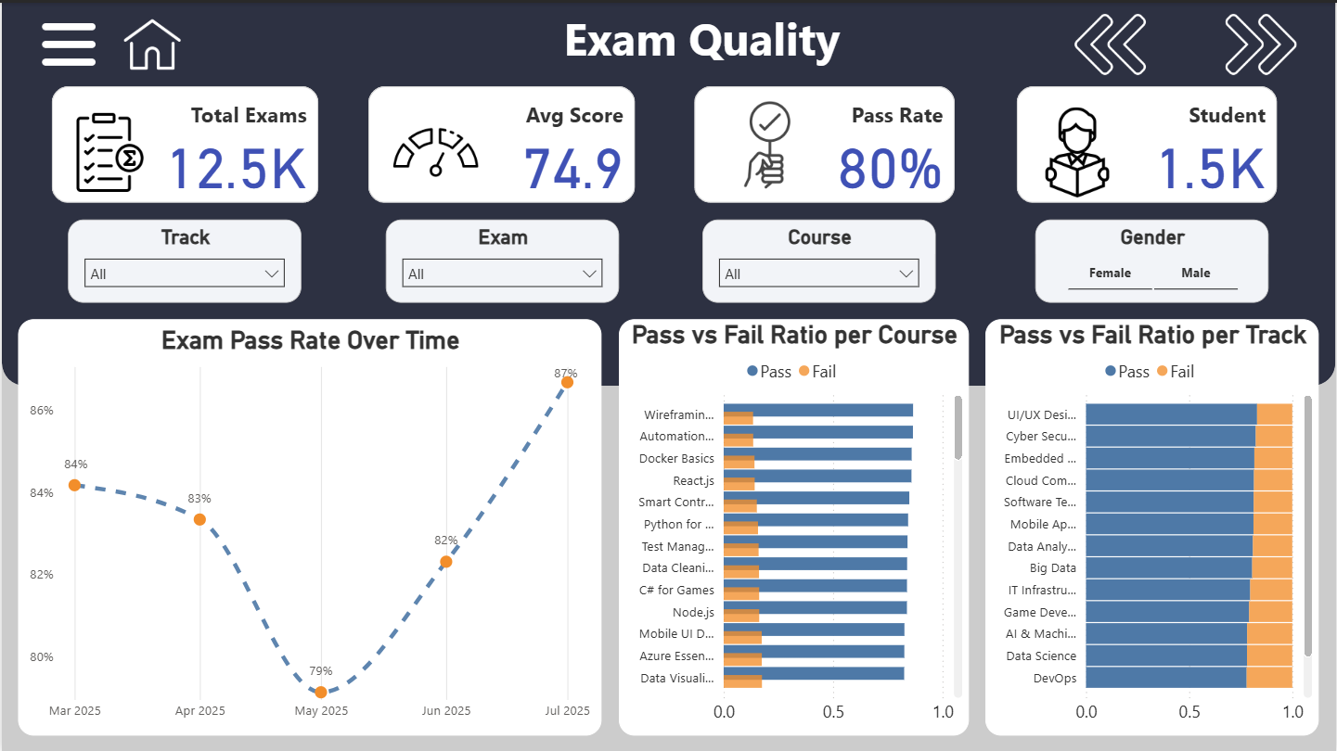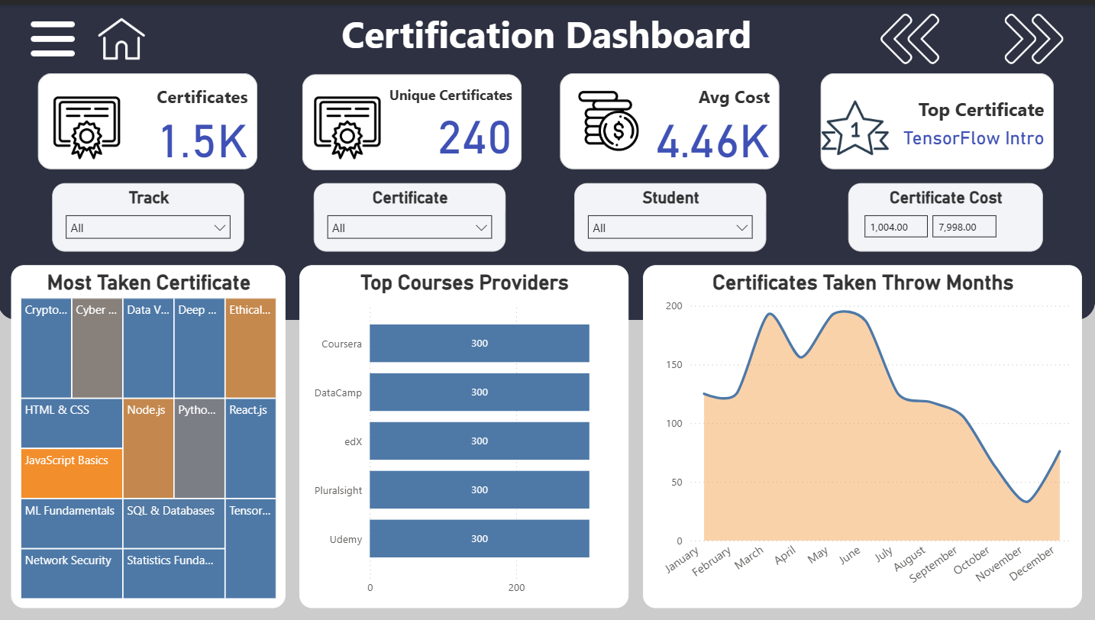

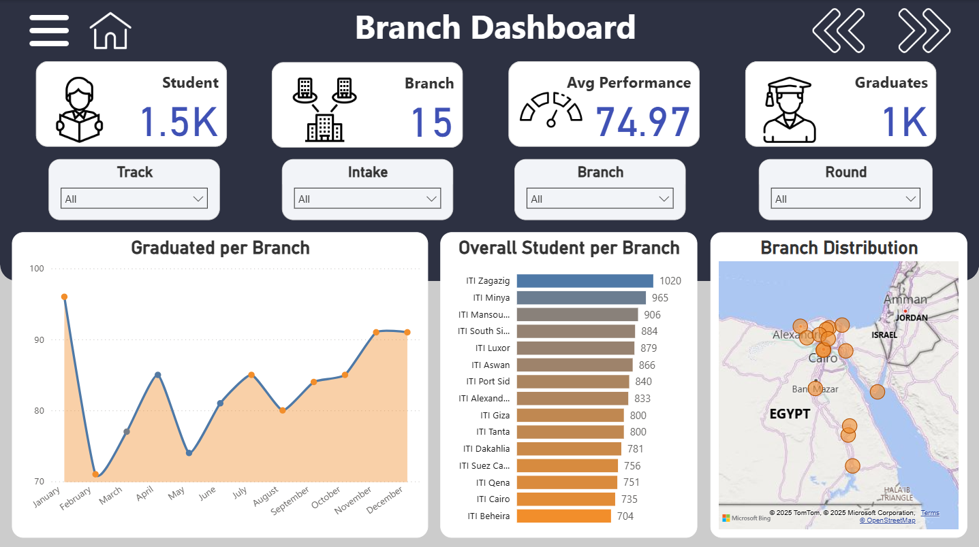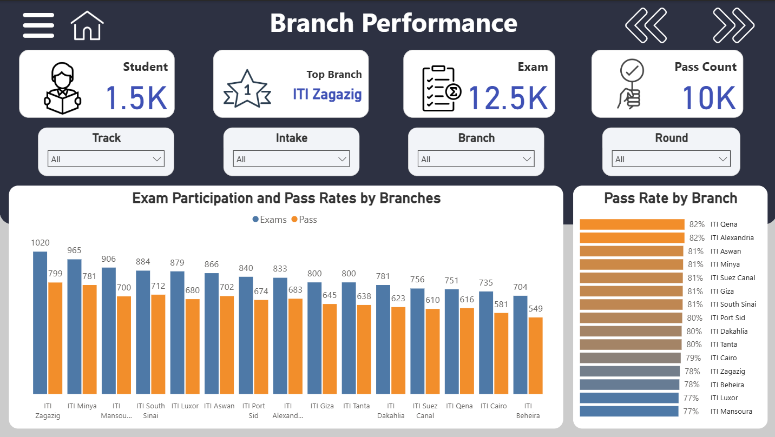

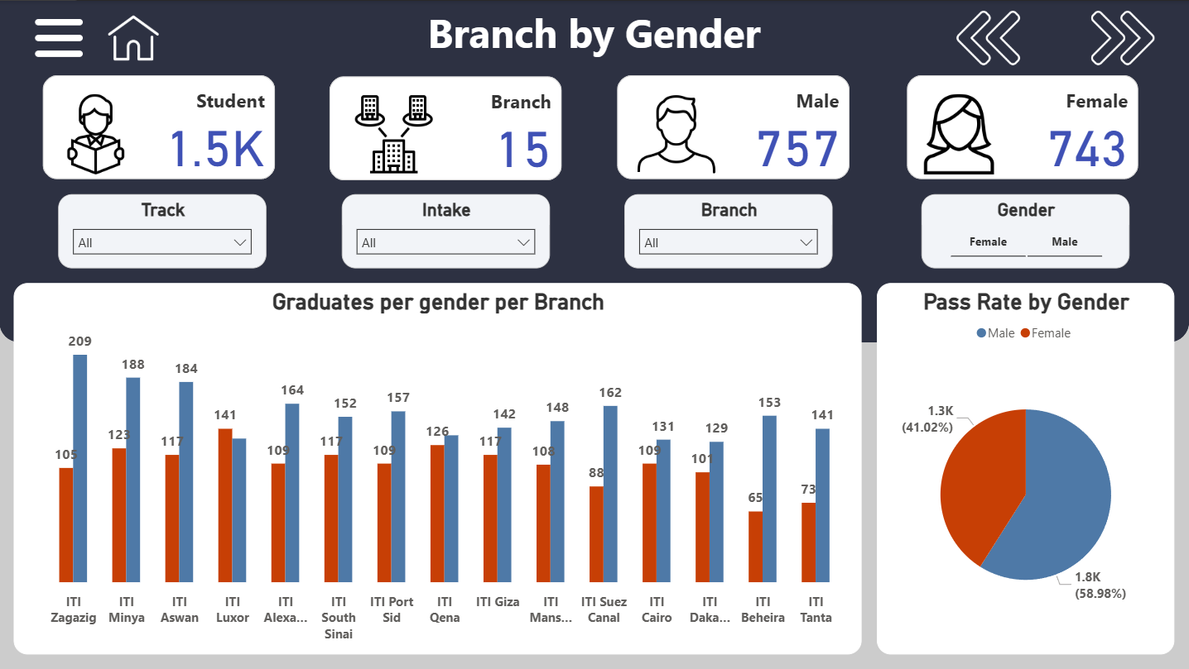

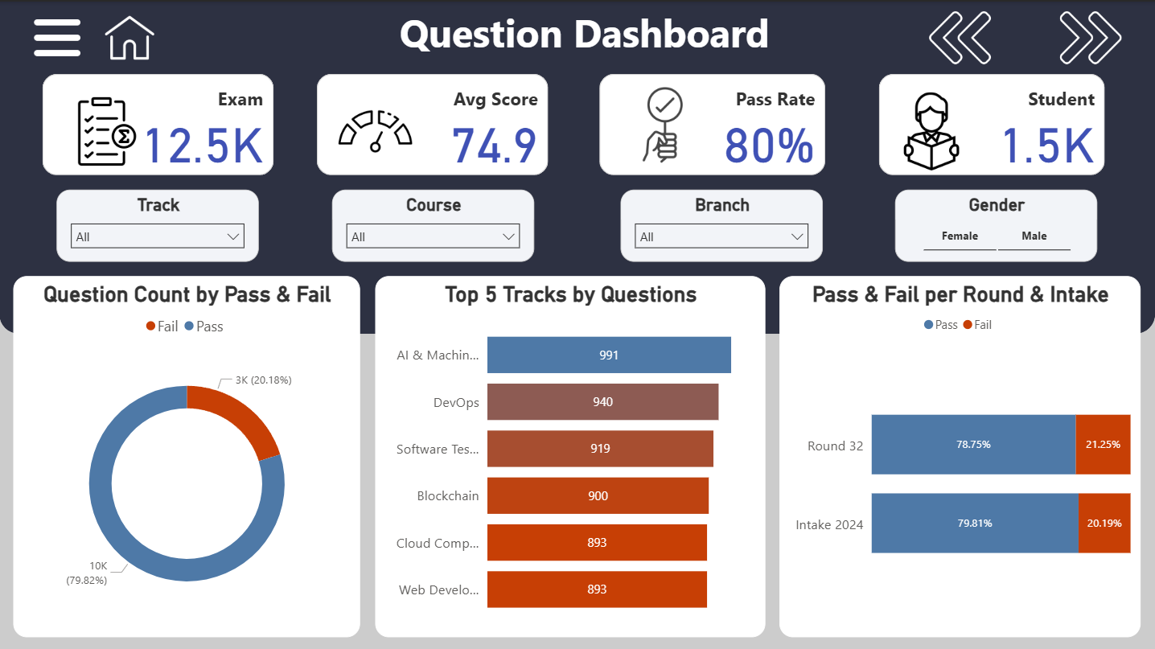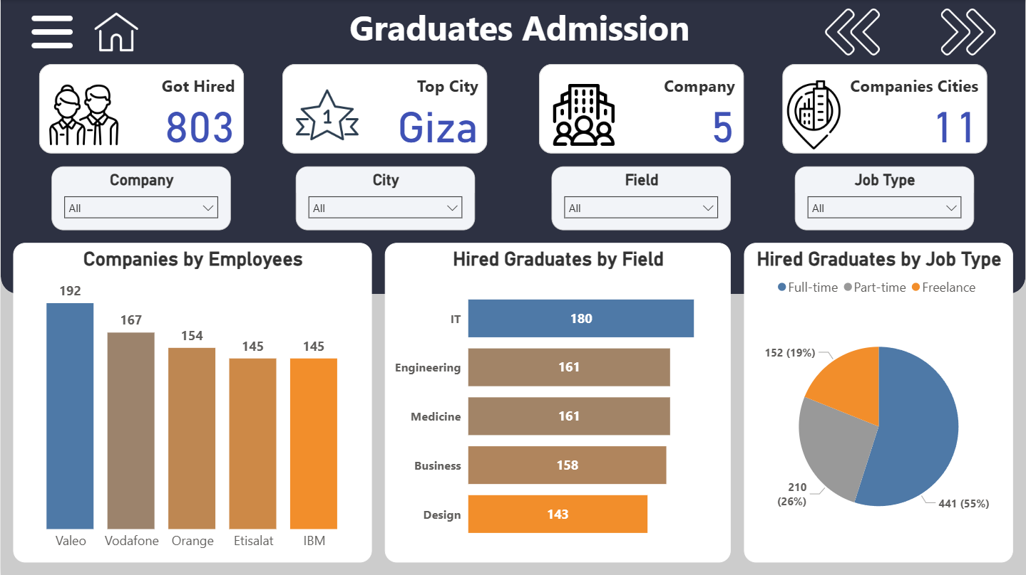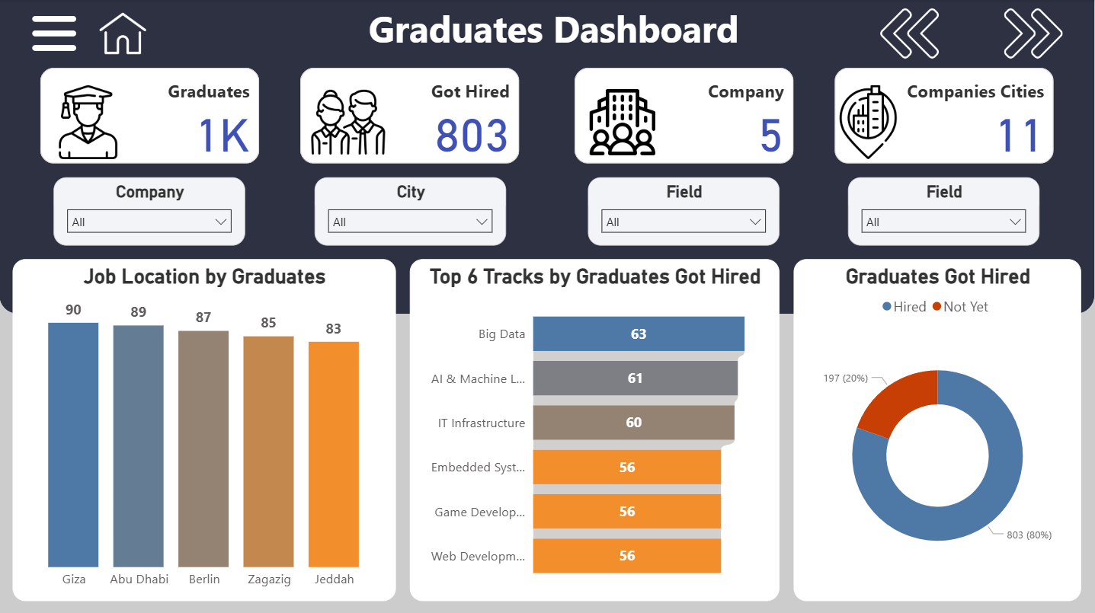

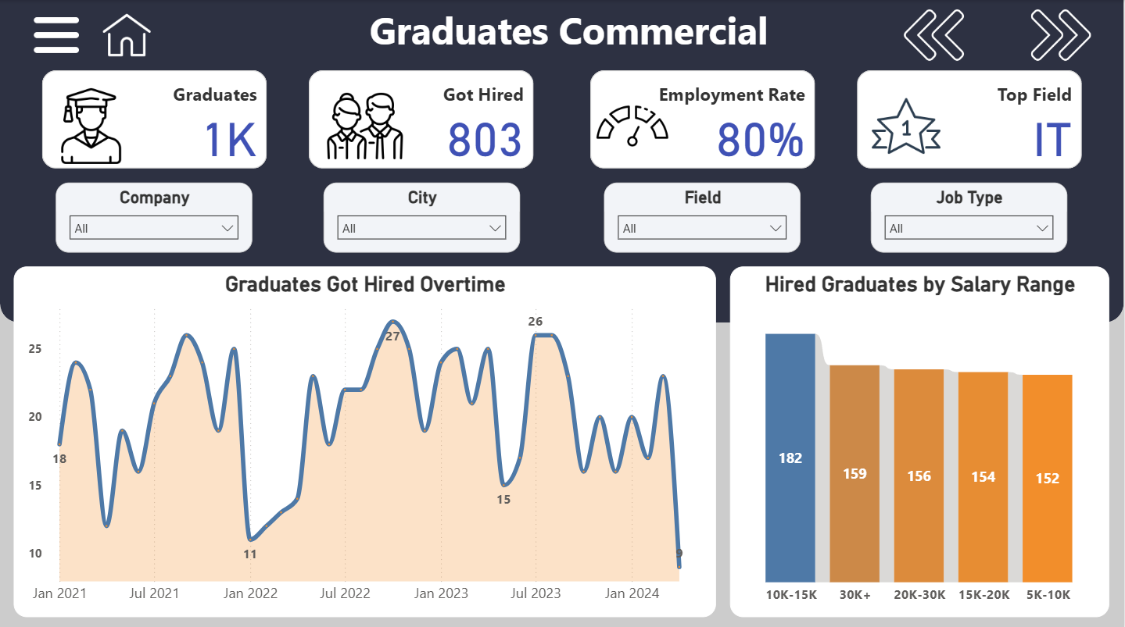

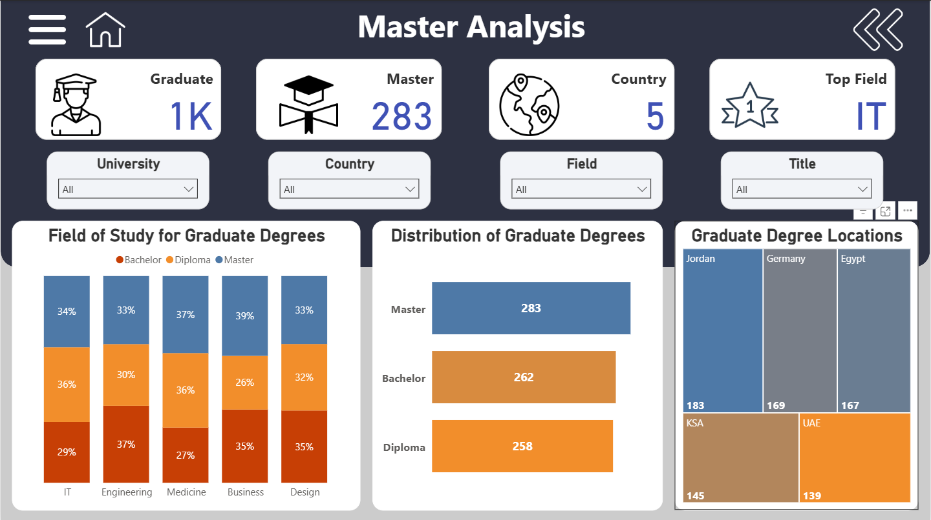

## Website

web application designed to automate the entire testing process. The platform is built using Python Flask for the backend, a MySQL database for data management, and standard web technologies (HTML, CSS, JavaScript) for a responsive and interactive frontend.

**System Architecture**

The application employs a modern, multi-tier architecture that separates concerns, ensuring scalability, security, and ease of maintenance.

* **Backend (Python Flask)**: The server-side logic is managed by Flask, a lightweight and powerful Python web framework. The backend is responsible for handling all API requests, managing user sessions, authenticating users, and orchestrating the entire exam workflow by communicating with the database.
* **Database (MySQL)**: At the core of the system is the Graduation_Project_OLTP relational database, which stores all data related to students, courses, questions, and exam results. Critically, all database interactions are encapsulated within stored procedures, a key design choice that enhances performance and provides a strong defense against SQL injection attacks.
* **Frontend (HTML, CSS, JavaScript)**: The user interface is crafted to be intuitive and responsive, providing a seamless experience on both desktop and mobile devices.
  + **HTML (index.html)**: Provides the structural foundation for the application's pages, including the login form, student dashboard, exam interface, and results summary.
  + **CSS (style.css)**: Defines the visual presentation, featuring a professional and modern aesthetic with a clean layout, a consistent color scheme, and responsive design principles that adapt to various screen sizes.
  + **JavaScript (app.js)**: Powers all client-side interactivity. It handles user input, manages asynchronous API calls to the Flask backend, controls the real-time exam timer, and dynamically updates the user interface without requiring page reloads.

**Core Examination Workflow**

The system guides students through a logical and automated four-step examination process:

1. **Login and Exam Generation**: A student initiates the process by logging in with their email, password, and selected course. The Flask backend validates these credentials against the Student table. Upon successful authentication, the system calls the sp_generate_exam_on_login stored procedure, which dynamically creates a new, unique exam instance in the database and returns an exam_id. This ensures each exam attempt is a distinct record.

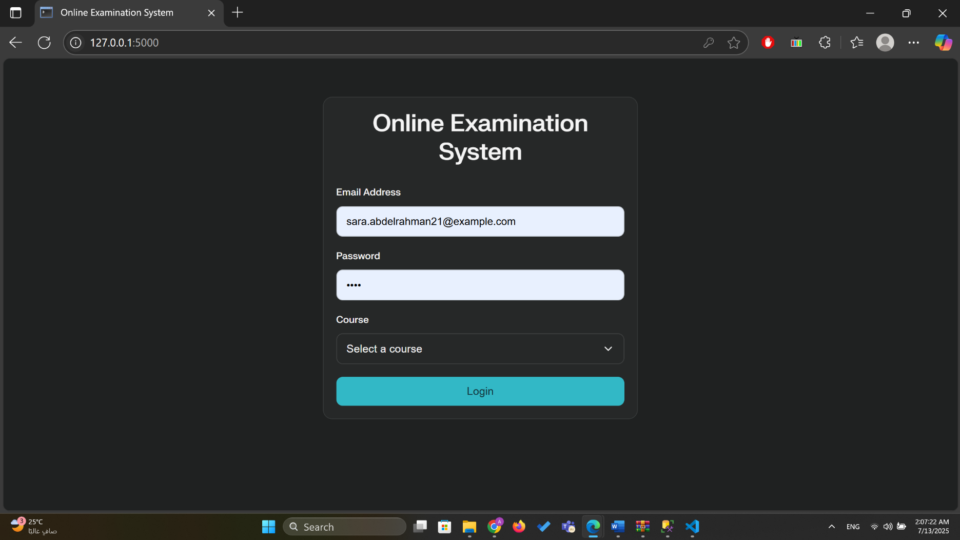

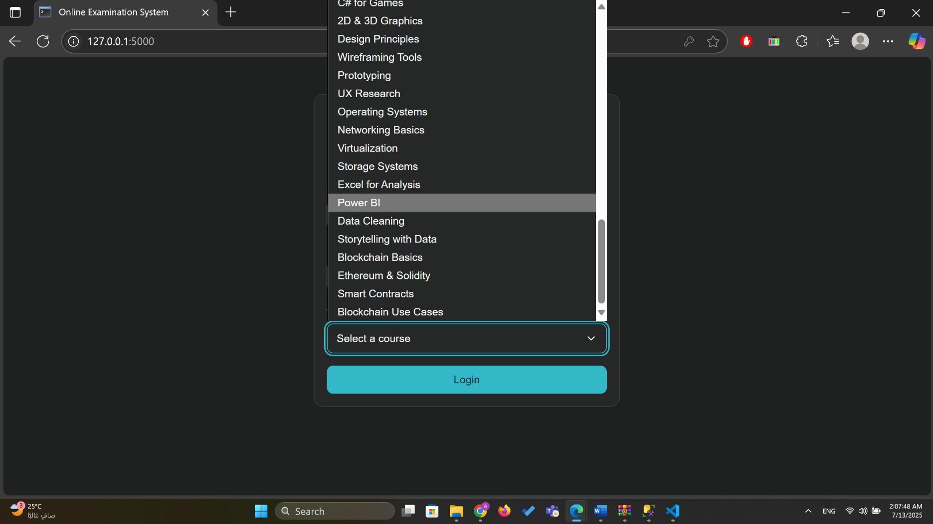

1. **Starting the Exam**: When the student clicks "Start Exam," the backend uses the sp_start_exam procedure. This procedure, in turn, calls sp_GenerateExamQuestions to randomly select a set of 10 questions for the specified course. To display the options for each question, the system fetches choices using the sp_GetAnswerChoices procedure.

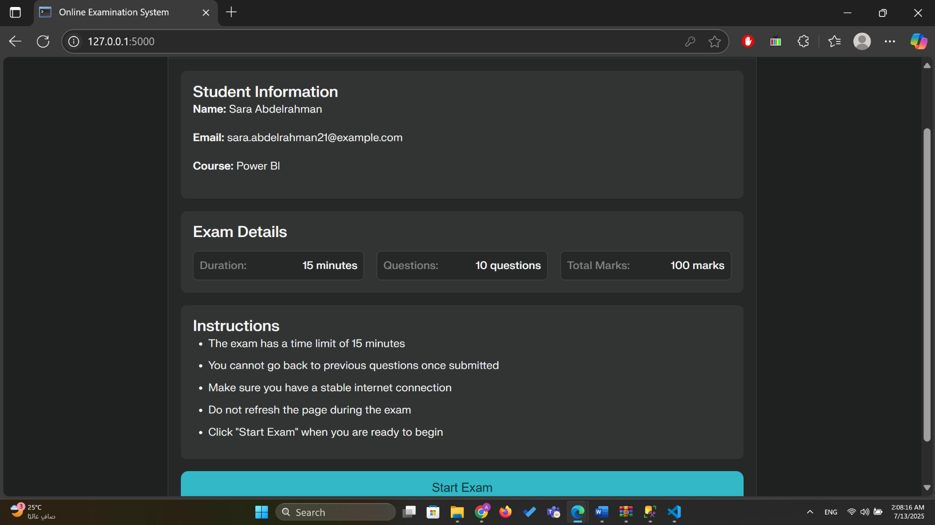

1. **Exam Submission and Automated Grading**: After the student completes the exam and submits their answers, the backend executes a precise sequence of stored procedures to automate the grading process:
   * First, sp_InsertStudentAnswer is called for each question to securely log the student's chosen answer.
   * Next, sp_CorrectAnswersAndUpdateGrades is executed. This procedure compares the student's answers to the correct ones stored in the database, assigns a grade for each question, and calculates the final percentage score.
   * Finally, sp_InsertExamResult is called to record the student's overall result, including the percentage and a "Pass" or "Fail" status, into the Exam_Result table.

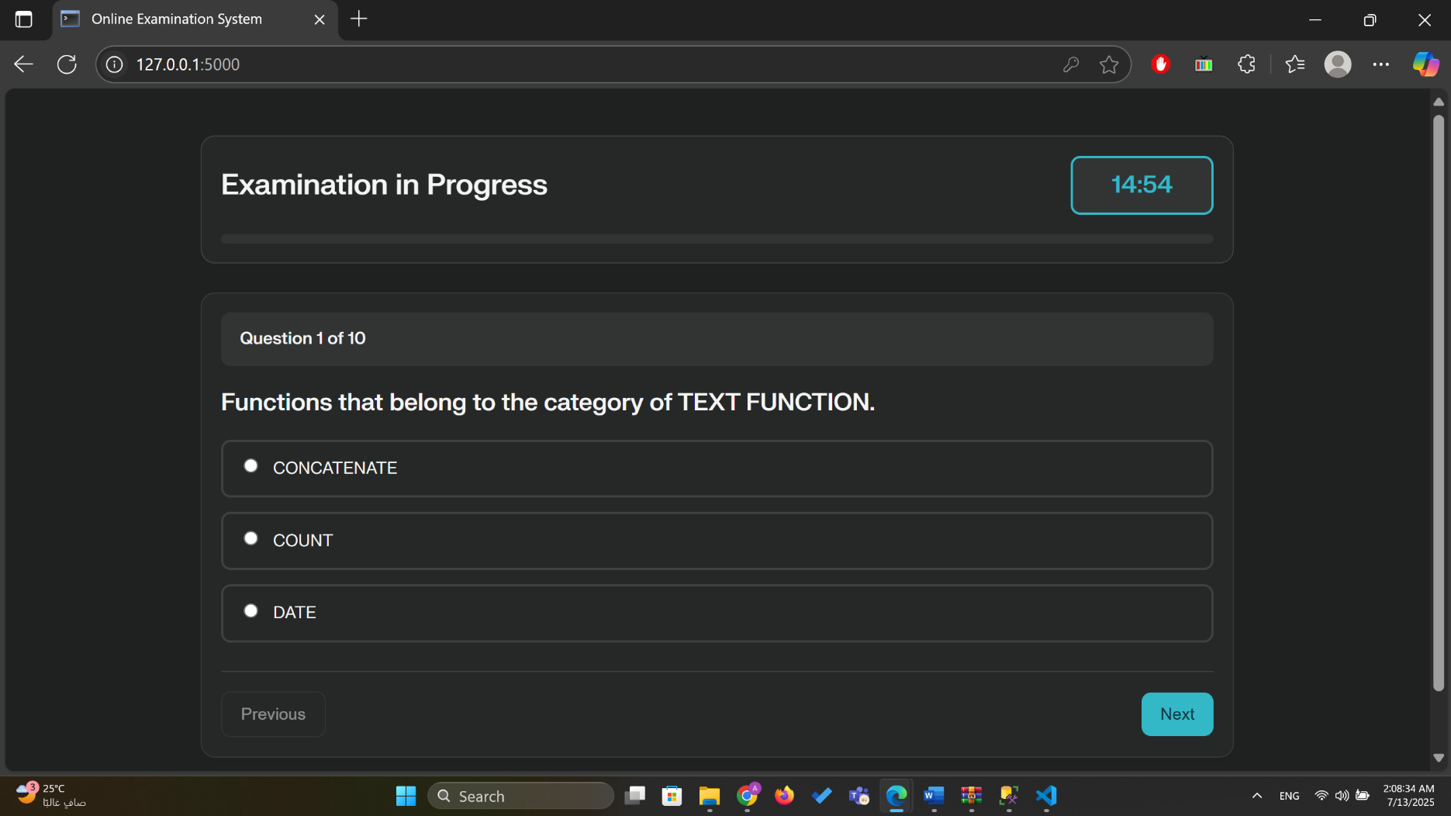

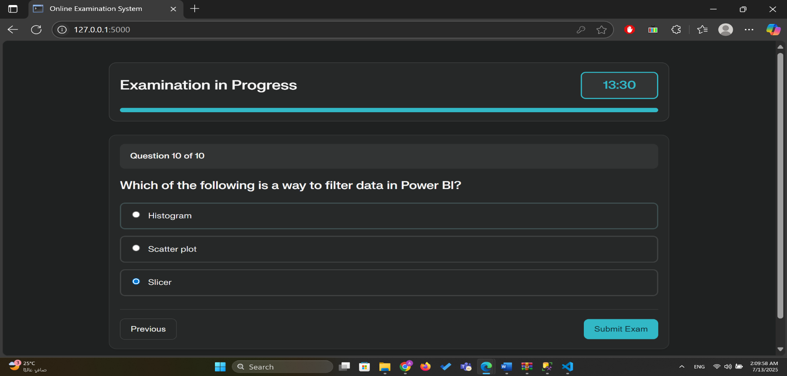

1. **Results Display**: The student is immediately redirected to a results page that provides a comprehensive summary of their performance. This includes their final score, the total number of correct and incorrect answers, and the time taken to complete the exam.

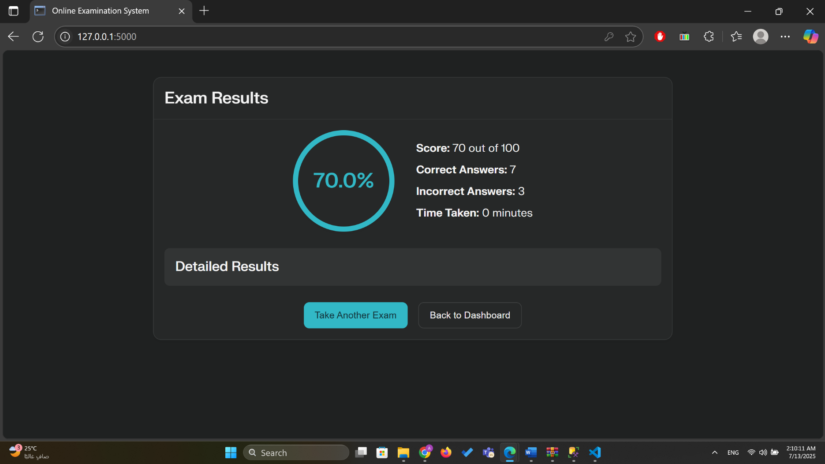

**Key Website Features**

The application incorporates a range of features designed to enhance functionality, user experience, and security.

**User Interface and Experience**

* **Responsive Design**: The user interface, governed by style.css, is fully responsive and ensures a consistent and accessible experience on desktops, tablets, and smartphones.
* **Real-time Feedback**: The application provides immediate feedback, such as error messages on the login form and a real-time countdown timer during the exam. The timer changes color to warn the student as time runs low, creating a sense of urgency.
* **Interactive Exam Elements**: A visual progress bar keeps the student informed of their progress, while interactive radio buttons allow for easy answer selection.

**Security**

* **SQL Injection Prevention**: By using parameterized stored procedures for all database operations, the application is protected against SQL injection, one of the most common web security vulnerabilities.
* **Session Management**: Flask's secure session management is used to track authenticated students, ensuring that only logged-in users can access the exam and submit answers.
* **Basic Anti-Cheating Measures**: The frontend JavaScript includes simple but effective measures to deter cheating. It disables the use of developer tools and context menus and alerts the user if they attempt to switch tabs during the exam.

⁂

1. [app.py](http://app.py)

1. [project-setup.md](http://project-setup.md)
2. exam_procedures.sql
3. index.html
4. style.css
5. app.js